E-Health Methods

Contents

E-Health 6

Digital Transformation 6

Digital Medicine 6

Verification and Validation 6

E-Health data 7

Data Flow in specialized healthcare 7

Interoperability 7

Medical Data 7

Modifiers 8

Data Uncertainty 8

From data to knowledge-based systems 8

Types of medical data 9

Narrative data 9

Recorded signals 9

Medical Images 9

Drawings and photographs 9

Data recording 9

Devices for data collection 10

The uses of medical data 10

Anticipate future problems 10

Record standard preventive measures 10

Identify deviations from expected trends 11

Provide a legal record 11

Support clinical research 11

Decision making 11

Terminologies: classification and ontologies 12

Clinical ideas 12

Terminology 12

Concepts 12

Pre-coordinated terminology 13

Post-coordinated terminology 13

Basic uses of terminology 13

Classifications: purpose and properties 13

Ontology 14

International classification of Disease (ICD) 14

ICD purposes and uses 14

SNOMED CT 15

Basic elements 15

Concepts 15

Descriptions 16

Relationships 17

A wrap up on SNOMED CT 19

Logical model 19

Briefly 20

Benefits 20

Example - Pre-coordinated and post-coordinated terminology 20

Relationships features 21

Unified Medical Language System 22

UMLs benefits 23

Metathesaurus 23

Semantic Network 26

SPECIALIST Lexicon 27

Lexical Entry 28

Lexical Tools 28

UMLS users and uses 29

Importance of UMLs 29

Natural Language Processing 29

Why NLP is possible? 29

Linguistic knowledge 30

NLP is a complex task 30

How NLP method works 30

Metamap 31

Methodology to design, develop and evaluate e-health technologies 34

Acceptance, Adoption and Adherence: 3 challenges 34

System development 34

Proposed Solution 35

Design principles 35

Multidisciplinary development team 35

CeHres roadmap 36

Requirements development approach 38

Methods to evaluate novel e-health solutions 41

Reliability 42

Validity 42

How to assure the reliability and validity of a new instrument 43

Correlation coefficients 43

Interclass Correlation Coefficients 44

Relative validity 44

Band-Altman Plot 45

Sum-Up on relative/absolute reliability/validity 47

Sample Size 47

Comparison with clinical scales 47

Usability satisfaction and acceptance 47

Sum up 48

Case study 48

Digital medicine for Ageing in place 53

Proposed solution 54

Smart internet of things objects 54

Handwriting monitoring 54

Gait monitoring 57

Grip force monitoring 58

The new frontier 59

Use of the object 60

Serious games to characterize the graphic gesture in pre-school age 60

Diagnostic process 60

Stakeholders 60

The IndiPote(dn)S project 61

Phases 61

The needs: 61

Needs to requirements 61

Technology 62

Serious game 62

Implicit and explicit objectives 62

Alterations in dysgraphic writing 62

Value proposition 63

Evaluate the developed technology? 63

Longitudinal study and collected data 65

Usability: Pictorial System Usability Scale 66

Serious games for empowerment 66

Strategies to maximize engagement 66

Iterative development and testing process 67

Towards a new school model 67

E-Health for Clinical Research Informatics 68

Case series and case reports 68

Case Control Studies 69

Cohort Studies 69

Randomized Controlled Trials (RCTs) 69

Blindness 69

Systemati reviews 69

Meta Analysis 70

Cochrane Library 70

Transfering evidence into practice 70

International clinical guidelines and clinical pathways 70

RCTs design 70

Bias in RCTs 71

Clinical research process 71

RCT process outputs 73

Tools for clinical research informatics 73

Overview of the tools 73

Clinical Trial Management Systems (CTMS) 73

Electronic data capture systems 74

Examples of clinical oucome assessment 74

Electronic Patient-Reported Outcome Measure (ePROM) 75

Which m-health applications can be integrated in RCT? 75

E-Health CONSORT statement 75

Decentralized RCTs 75

Challenges for decentralize control trials 75

Recommendetions for DCT 76

Biomedical Decision Making: probabilistic clinical reasoning 76

Diagnostic process 76

Methods to assess pretest probability 77

Classification of diagnostic test results 77

Bias in measurement of test characteristics 78

Post-test Probability 78

Common problems with probabilistic reasoning 79

Expected-value decision making 79

Decision analysis 79

Other modelling approaches 82

The role of probability and decision analysis in medicine 82

Clinical Decision Support Systems 82

Basic requirements 83

How to characterize CDSS 83

The intended system function 83

Modality of giving advice 83

The communication style 84

Underlying decision making process 84

Human-computer interaction 84

Example of current CDSS tools 84

Athena CDS 85

Reasons for the slow uptake of CDSS 85

Imaging Informatics 85

Image quality 85

Image content 86

Knowledge representation 86

Anatomy 86

Imaging features 86

Semantic representation of image contents 86

Semantic annotation 86

Image Processing 87

Image interpretation and computer reasoning 87

Image retrieval 87

Computer assisted detection (CAD) 88

Computer assisted diagnosis (CADx) 88

# E-Health

E-Health is an emerging field referring to health services and information delivered or enhanced through the Internet and related technologies.

The e’s in e-Health:

* **Efficiency**: decreasing costs by avoiding duplicative or unnecessary diagnostic or therapeutic interventions, through enhanced communication possibilities between health care establishments, and through patient involvement.
* **Enhancing quality of care**: by allowing comparison between different providers, involving consumers as additional power for quality assurance, and directing patient streams to the best quality providers.
* **Evidence based**: the effectiveness and efficiency of e-health interventions should be proven by rigourous scientific evaluation.
* **Empowerment of consumers and patients**: by making the knowledge bases of medicine and personal electronic records accessible, e-health opens new avenues for patient-centered medicine.
* **Encouragement**: Creating a new relationship between the patient and the health professional, towards a true partnership, where decisions are made in a shared manner.
* **Education**: Online sources for physicians (continuing medical education) and consumers (health education, tailored preventive information for consumers).
* **Enabling information exchange**: in a standardized way between health care stakeholders.
* **Extending conceptually and geographically**: E-health enables consumers to easily obtain health services online from global providers.
* **Ethics**: new challenges and threats to ethical issues, such as online professional practice, informed consent, privacy, and equity issues.
* **Equity**

## Digital Transformation

Digital transformation is based on digital technologies and it’s an opportunity to revolutionize the model of care. Digital transformation needs changes both in culture and organization. Moreover, devices must be reliable and be connected to the healthcare system.

## Digital Medicine

By digital medicine we inted all the softwares that measure and intervene. It’s a closed loop around the patient/user with the goal of improving his health. A digital medicine device/software is a certified medical device. Digital medicine softwares are and must be based on scientific evidence.

### Verification and Validation

With the verification process we are verifying that the software has the expected behaviour.

With validation, which is a more difficult process that involves clinicians and target users, we are verifying the usability and the outcome of the tool.

Verification and validation together, indicate whether a digital measurement tool is fit-for-purpose.

# E-Health data

Gathering data and interpreting their meaning are central to the health care process. Data are crucial to the process of decision making:

* Basis for categorizing the problems a patient may have or for identifying subgroups within a population of patients
* Help a physician to decide what additional information is needed and what action should be taken to gain a greater understanding of a patient’s problem or to treat most effectively the problem that has been diagnosed.

## Data Flow in specialized healthcare

Modern medicine is highly specialized. The achievement of high quality healthcare may imply data flow among physicians/providers (interoperability). The issue is more relevant for the management of chronic diseases which imply also higher costs.

# Interoperability

The three layers of interoperability are:

* **Organisational Interoperability** is the will and ability to work together and exchange information. It depends on the overarching environment composed of laws, policies, and cooperation agreements.
* **Semantic Interoperability** allows both sides to understand the meaning of the information exchanged across cultural and linguistic barriers.
* **Technical Interoperability** enables the exchange of information from a technical standpoint and guarantees:
  + Data security and privacy
  + Data integrity
  + Access to relevant data associated with an identified patient

# Medical Data

We consider a medical datum to be any single observation of a patient (e.g., a temperature reading, a red blood cell count, a past history of a rush, or a blood pressure reading).

A medical datum is a single observation about a patient, medical data are multiple observations. Such data may involve several different observations made concurrently, the observation of the same patient parameter made at several points in time, or both. Thus, a single datum generally can be defined by 4 elements:

1. The patient in question
2. The parameter being observed (e.g., liver size, urine sugar value, history of rheumatic fever, heart size on chest X-ray film)
3. The value of the parameter in question (e.g., weight is 70 kg, temperature is 98.6˚F)
4. The time of the observation (e.g., 2:30AM on 14FEB1997)

It is a matter of perspective whether a single observation is in fact more than one datum. A blood pressure of 120/80 might well be recorded as a single datum point in a setting where knowledge that a patient’s blood pressure is normal is all that matters. If the difference between diastolic (while the heart cavities are beginning to fill) and systolic (while they are contracting) blood pressures is important for decision making or for analysis, however, the blood pressure reading is best viewed as two pieces of information (systolic pressure = 120 mmHg, diastolic pressure = 80 mmHg). Human beings can glance at a written blood pressure value and easily make the transition between its unitary view as a single datum point and the decomposed information about systolic and diastolic pressures.

## Modifiers

It is important to keep a record of the circumstances under which a datum was obtained. For example, was the blood pressure taken in the arm or leg? Was the patient lying or standing? Was the pressure obtained just after exercise? During sleep? What kind of recording device was used? Was the observer reliable?

Such additional information, called modifiers, can be of crucial importance in the proper interpretation of data. Two patients with the same basic complaint or symptom often have markedly different explanations for their problem, revealed by careful assessment of the modifiers of that complaint.

## Data Uncertainty

A related issue is the uncertainty in the values of data. It is rare that an observation, even one by a skilled clinician, can be accepted with absolute certainty. One technique is to collect additional data that will either confirm or eliminate the concern raised by the initial observation. This solution is not always appropriate, however, because the costs of data collection must be considered. The additional observation might be expensive, risky for the patient, or wasteful of time during which treatment could have been instituted. The idea of trade-offs in data collection thus becomes extremely important in guiding health care decision making.

# From data to knowledge-based systems

“A **datum** is a single observational point that characterizes a relationship. It generally can be regarded as the value of a specific parameter for a particular object (e.g., a patient) at a given point in time.”

**“Knowledge**, then, is derived through the formal or informal analysis (or interpretation) of data. Thus, it includes the results of formal studies and also common-sense facts, assumptions, heuristics (strategic rules of thumb), and models—any of which may reflect the experience or biases of people who interpret the primary data.”

“The term **information** encompasses both organized data and knowledge, although data are not information until they have been organized in some way for analysis or display.”

Thus, when data is interpreted in a specified context provide information.

A **database** is a collection of individual observations without any summarizing analysis.

A medical record is thus primarily viewed as a database, the place where patient data are stored. A knowledge base, on the other hand, is a collection of facts, heuristics, and models that can be used for problem solving and data analysis. If the knowledge base provides sufficient structure, including semantic links among knowledge items, the computer itself may be able to apply that knowledge as an aid to case-based problem solving.

# Types of medical data

## Narrative data

Narrative data account for a large component of the information that is gathered in the care of patients:

* The patient’s description of his / her present illness,
* Responses to focused questions from the physician
* The patient’s social and family history
* The general review of systems that is part of most evaluations
* The clinician’s report of physical examination findings

Generally, is gathered verbally and is recorded as text in the medical record.

Some narrative data are loosely coded with shorthand conventions (abbreviations) known to health personnel. Many are not standard and can have different meanings depending on the context in which they are used: “MI” – “mitral insufficiency” (leakage in one of the heart’s valves) or “myocardial infarction” (heart attack).

## Recorded signals

In some fields of medicine, analog data in the form of continuous signals are particularly important. When such data are stored in medical records, a written interpretation of its meaning is included.

## Medical Images

X-Ray, CT, Ultrasound, PET, CT-PET, MRI, and others. Typically, a clinical interpretation by a specialized radiologist is required.

## Drawings and photographs

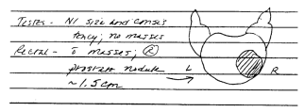Visual images, either acquired from machines (photographs) or sketched by the physician (drawing), are another important category of data. It is common for physicians to draw simple pictures to represent abnormalities that they have observed. Example: a sketch is a concise way of conveying the location and size of a nodule in the prostate gland.

# Data recording

Physicians and other health care personnel are taught from the outset that it is crucial that they do not trust their memory when caring for patients. They must record their observations, as well as the actions they have taken and the rationales for those actions, for later communication to themselves and other people.

Health data on patients and populations are gathered by a variety of health professionals:

* Nurses often build relationships with patients that uncover information and insights that contribute to proper diagnosis, to understanding of pertinent psychosocial issues, or to proper planning of therapy or discharge management
* Office staff and admissions personnel gather demographic and financial information.
* Physical or respiratory therapists record the results of their treatments and often make suggestions for further management.
* Laboratory personnel perform tests on biological samples, such as blood or urine, and record the results for later use by physicians and nurses.
* Radiology technicians perform X-ray examinations; radiologists interpret the resulting data and report their findings to the patients’ physicians.
* Pharmacists may interview patients about their medications or about drug allergies and then monitor the patients’ use of prescribed drugs.

## Devices for data collection

* laboratory instruments
* imaging machines
* monitoring equipment
* measurements able to take a single reading (thermometer, spirometers, ECG…

These measurements can be shown on a display, printed, saved electronically, or can require an expert to interpret the output and provide a referral on it.

Now data are also coming from smartphones and wearables devices. But there is the crucial need of being sure that data is valid and reliable. We need a technology able to recognize if the data produced is reliable or not.

# The uses of medical data

Data should be used to improve the health of the patient but also for other purposes such as clinical research, standards development, databse population and many others.

## Anticipate future problems

Data gathered routinely in the ongoing care of a patient may suggest that he/she is at high risk of developing a specific problem even though he or she may feel well and be without symptoms at present. Medical data therefore are important in screening for risk factors, following patients’ risk profiles over time, and providing a basis for specific patient education or preventive interventions, such as diet, medication, or exercise. Perhaps the most common examples of such ongoing risk assessment in our society are routine monitoring for excess weight, high blood pressure, and elevated serum cholesterol levels. In these cases, abnormal data may be predictive of later symptomatic disease; optimal care requires early intervention before the complications have an opportunity to fully develop

## Record standard preventive measures

The medical record also serves as a source of data on interventions that have been performed to prevent common or serious disorders. Other important preventive interventions include immunizations: the vaccinations that begin in early childhood and may continue throughout life, including special treatments administered when a person will be at particularly high risk (e.g., injections of gamma globulin to protect people from hepatitis, administered before travel to areas where hepatitis is endemic). When a patient comes to his local hospital emergency room with a laceration, the physicians routinely check for an indication of when he most recently had a tetanus immunization. When easily accessible in the record (or from the patient), such data can prevent unnecessary treatments (in this case, an injection) that may be associated with risks or significant costs.

## Identify deviations from expected trends

Data often are useful in medical care only when viewed as part of a continuum over time. An example is the routine monitoring of children for normal growth and development by pediatricians.

## Provide a legal record

Another use of medical data, once they are charted and analyzed, is the use as the foundation for a legal record to which the courts can refer. The medical record is a legal document; the responsible individual must sign most of the clinical information that is recorded. In addition, the chart generally should describe and justify both the presumed diagnosis for a patient and the choice of management. Data do not exist in a generally useful form unless they are recorded. The legal system stresses this point as well. Providers’ unsubstantiated memories of what they observed or why they took some action is of little value in the courtroom. The medical record is the foundation for determining whether proper care was delivered. Thus, a well-maintained record is a source of protection for both patients and their physicians.

## Support clinical research

Support clinical research through the aggregation and statistical analysis of observations gathered from populations of patients.

Randomized clinical trial (**RCT**): RCTs typically involve the random assignment of matched groups of patients to alternate treatments when there is uncertainty about how best to manage the patients’ problem. The variables that might affect a patient’s course (e.g., age, gender, weight, coexisting medical problems) are measured and recorded. RCT are tipically double blind (i.e., neither the researchers nor the subjects know which treatment is being administered) and multicentric.

**Epidemiology**: medical knowledge also can be derived from the analysis of large patient data sets even when the patients were not specifically enrolled in an RCT. Much of the research in the field of epidemiology involves analysis of population-based data of this type. Our knowledge of the risks associated with cigarette smoking, for example, is based on irrefutable statistics derived from large populations of individuals.

## Decision making

Studies of medical decision makers have shown that strategies for data collection and interpretation are mainly based on an iterative process known as the hypothetico-deductive approach. The central idea is one of sequential, staged data collection, followed by data interpretation and the generation of hypotheses, leading to hypothesis-directed selection of the next most appropriate data to be collected. As data are collected at each stage, they are added to the growing database of observations and are used to reformulate or refine the active hypotheses. This process is iterated until one hypothesis reaches a threshold level of certainty (e.g., it is proved to be true, or at least the uncertainty is reduced to a satisfactory level). At that point, a management, disposition, or therapeutic decision can be made. Physicians refer to active hypotheses as the differential diagnosis.

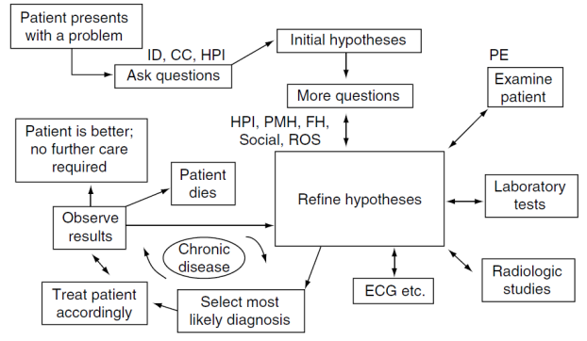

Figure 1: A schematic view of the hypothetico-deductive approach. The process of medical data collection and treatment is intimately tied to an ongoing process of hypothesis generation and refinement.

# Terminologies: classification and ontologies

We need terminologies for various reasons:

* Different health care professionals contribute to data collection and interpretation.
* Communication and patient data sharing among authorized health care professionals are central points in healthcare.
* Developing coded medical information is crucial to interpret patient documentation.
* Data should be available for epidemiological studies and research.
* Automatic interpretation from PC programs should be possible.

## Clinical ideas

Clinical ideas are the essence of anything we want to record about the health of the person. They are the building blocks for EHR. For example: otitis media, ear infection, middle ear, etc.

## Terminology

* A terminology is the set of special words or phrases that are used in a particular field.
* Like a vocabulary, but not for an entire language, limited to a specific field: for example, medicine or mathematics, or a specialty.
* Terminologies are lists of coded and motivated expressions.
* Terminologies are based on concepts and associations between them.
* Terminologies are built according to specific rules or procedures (models).

## Concepts

* A concept can be defined as a single unit of thought, a unique clinical idea which has a specific meaning within its scope of use
* Simple concepts can be defined through a single term: for example, "brain"
* To represent complex concepts, two alternatives are usually followed:
  + Pre-coordinated terminology
  + Post-coordinated terminology

### Pre-coordinated terminology

Creating a definition and assigning a unique identification code to single or aggregates of predefined concepts. In this case, a terminology is composed by the **predefined list** of all the simple and the complex concepts of the domain of interest and their modifications. An example of pre-coordinated terminology is a **classification**.

#### Pros and cons of pre-coordinated terminology

Advantages:

* Can easily convey complex information without ambiguity.
* All those combinations of atomic concepts that are meaningless, or not desirable are eliminated, as the only permitted combinations of atomic concepts are the default ones.

Disadvantages:

* The extensive (excessive?) specificity makes it difficult to access the vocabularies to those who are unfamiliar to the scope of the terms that are described.
* It is almost impossible to classify new concept aggregates. Pre- defined complex concepts are composed by individual concept terms which are combined in a different way, and therefore those individual concepts are redundant.
* Concepts are repeated many times in the vocabulary.

### Post-coordinated terminology

The second option is to define and assign a code to atomic concepts. These latter can then be combined to obtain the concept aggregates: for example, perforated ulcer, where perforated is the modifier of the original simple concept. In this case, **aggregates** of single concepts can be **built when needed**.

So post-coordinated allows us to build concepts when needed without having all the knowledge a-priori.

#### Pros and cons of post-coordinated terminology

Advantages:

* Smaller than pre-coordinated ones, as total numbers, or identifiers to be assigned
* New concepts can be created aggregating basic or previously-generated concepts.

Disadvantages:

* Rules are needed for creating new terms in the right way.

## Basic uses of terminology

1. Abstraction and classification entail examination of the recorded data and then selection of items from a terminology with which to label the data (1-dimension hierarchy).
2. Representation is the process by which as much detail as possible is coded.

## Classifications: purpose and properties

Purpose: subdivision of phenomenon into classes that are the basis for ordering things.

Classifications are hierarchical and characterized by the following properties:

* univocity of concepts and identifiers.
* being omnicomprehensive, i.e., **pre-coordinated**.
* classes are mutually exclusive.
* being exhaustive Classifications have rules to assign codes (hierarchical ID).

Classifications are used for statistics, epidemiology, audit, planning, financial billing.

## Ontology

In computer science, an ontology can be considered the description of a domain expressed by their concepts, and the relationship among those concepts. Relationships can be hierarchical (e.g., a parent-child relationship) or nonhierarchical (e.g., is caused by). In e-health ontologies can allow semantic interoperability among different information systems, as they are able to connect different terminologies by their concepts. It can be used to connect concepts having the same meaning, even though they are expressed by different words. SNOMED CT / UMLS are examples of ontologies.

## International classification of Disease (ICD)

The International Classification of Disease, ICD has been developed by the World Health Organization. It is used by health care professionals to classify diseases and other health problems recorded on many types of health and vital records, including death certificates and death records. More than 100 countries use the system to report mortality data, a primary indicator of health status. About 70% of the world’s health expenditures (USD $ 3.5 billion) are allocated using ICD for reimbursement and resource allocation. ICD10 (the most recent in use) has been translated into 43 languages.

ICD is used for statistics and billing of hospitals, for example.

### ICD purposes and uses

* The ICD is the foundation for the identification of health trends and statistics globally.
* The ICD defines the universe of diseases, disorders, injuries, and other related health conditions.
* It organizes information into standard groupings of diseases, which allows for:
  + easy storage, retrieval, and analysis of health information for evidenced-based decision-making.
  + sharing and comparing health information between hospitals, regions, settings, and countries.
  + data comparisons in the same location across different time periods.
* ICD allows the counting of deaths as well as diseases, injuries, symptoms, reasons for encounter, factors that influence health status, and external causes of disease.

Any concept in ICD is uniquely identified by a certain identifier (ID), or code. The IDs are hierarchical: the assignement depends on the membership of a term to a certain class.

In Italy ICD-9 is used to code information obtained by the SDOs (Scheda di Dimissione Ospedaliera) while ICD-10 is adopted to code death causes for ISTAT reports.

#### Example - The ICD codes for COVID-19 disease outbreak

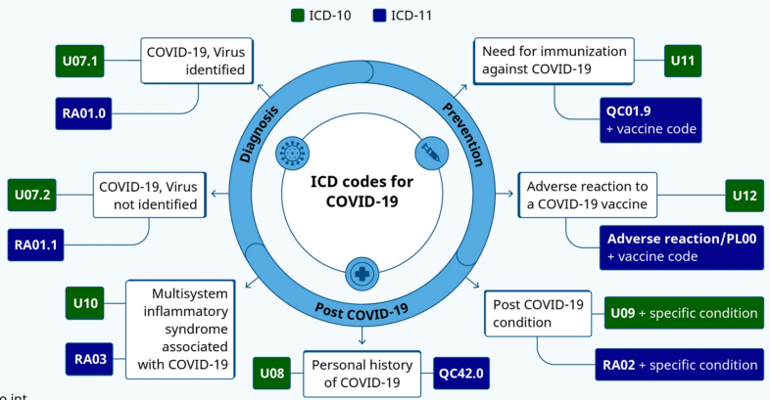

# SNOMED CT

SNOMED CT = **S**ystematized **No**menclature of **Med**icine - **C**linical **T**erms

SNOMED CT is the most comprehensive and precise clinical health terminology. SNOMED CT is used to:

* Code
* Retrieve (meaning-based retrieval)
* Analyze clinical data

It is a resource with scientifically validated clinical content. Enables consistent, processable representation of clinical content in electronic health records. It is mapped to other international standards, and it is already used in more than 50 countries.

## Basic elements

* **Concepts**: the basic units of SNOMED CT. They represent clinical idea. They are organized into hierarchies.
* **Descriptions**: these relate terms that name the concepts to the concepts themselves. Each concept has at least two descriptions (Fully Specified Name and Synonym).
* **Relationships**: relationships are the connections between concepts

### Concepts

Concepts represent distinct clinical meanings. Concept are identified by a unique numeric identifier (Concept ID) that never changes and a unique human readable name (Fully Specified Name) that specifies the meaning of the concept. Associated with each concept there is a set of names or terms (descriptions) and a set of relationships (the “logical definition”). There are currently more than 400000 concepts in SNOMED CT.

Concepts are organized in hierarchies.

#### Concept design

* Concept ID: a unique numeric identifier of up to 18 digits
* Versioning data to allow to deactivate it without deleting it
* Definition status
  + defined
  + primitive

### Descriptions

Descriptions relate the terms or names of a SNOMED CT concept to the concept itself.

Term: a phrase used to name a concept.

A single description associates a single term with a single Concept ID. Each of these descriptions has a unique Description ID, but all these descriptions are associated with a single concept (and a single Concept ID). Descriptions are an important interface property because they give end users the flexibility to use terms that they are familiar with. The Concept ID ties terms with the same meaning together to aid consistent interpretation and retrieval.

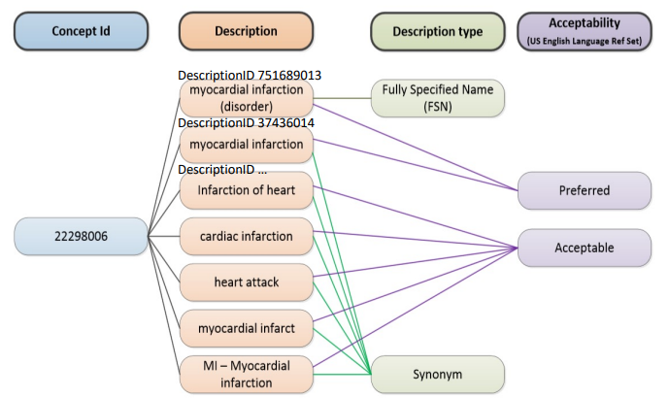

Acceptability: tells which terms is best to be used.

#### Description types

The *Fully Specified Name* (FSN) provides an unambiguous way to name a concept. It contains a hierarchy tag in brackets to indicate the type of concept, e.g., appendectomy (procedure). Synonyms are the rest of the names that may be used by clinicians to refer to a concept. They are used as user interface to search, select, and display. Each concept has at least one FSN and one synonym. An additional description type (not compulsory) is the text description which provide descriptive text about the concept.

#### Preferred term

It is the most common word or phrase used by clinicians to name a concept. This is the term to be displayed when a concept is selected. It is not a description type; they can vary according to language or dialects. It is the synonym marked as preferred in a particular language.

#### Description Design

* •Description ID (numeric id up to 18 digits not the Concept ID)
* Versioning data
* Concept ID to which it applies (permanent link)
* Human readable term
  + UTF-8
* Description type

Terms do not need to be unique. The same term can be used in different concepts:

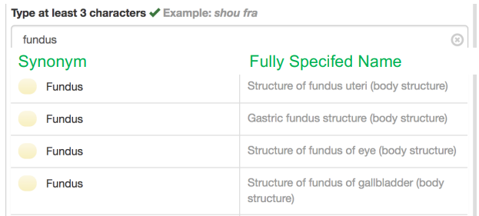

### Relationships

Relationships are the connections between concepts. Every SNOMED CT concept has at least one relationship to another concept. Relationships express defining characteristics of a concept. The list of relationships for a particular concept makes up the logical definition of that concept. There are two types of relationship:

* IS-A (sub/super-type or child/parent)
* Attribute

Example of relationship:

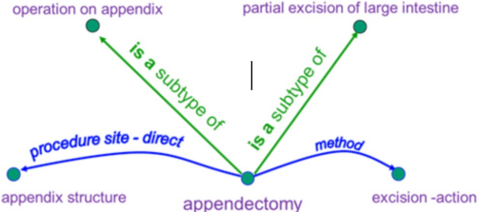

#### IS A (subtype) relationship

It creates a hierarchy of concepts linking all concepts to more general concepts (destination is the more general concept). It allows the description of different levels of detail. The subtype [child] (source of the relationship) is more specific than the supertype [parent].

Example supertype of appendectomy:

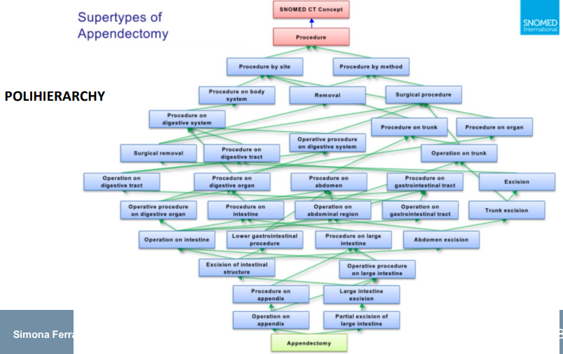

#### Attribute relationship

An attribute relationship contributes to the definition of the source concept by associating it with the value of a defining characteristic. The characteristic (attribute) is specified by the relationship type and the value is provided by the destination of the relationship. For example: “finding site” or “causative agent”.

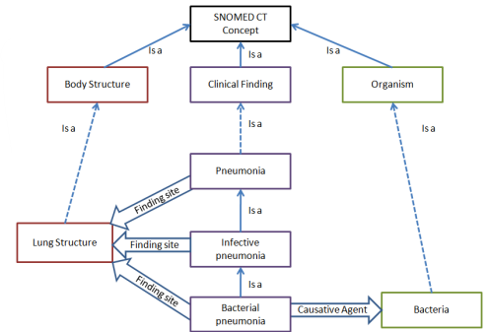

In the picture we see how bacterial pneumonia is caused by bacteria while infective pneumonia is not.

There are clear rules to define attributes of relationships. For example, the concept of entire femure as body structure cannot have a causative agent as attribute cause a body structure is not caused by anything.

#### Relationship design

* Relationship ID (numeric id up to 18 digits not the Concept ID)
* Versioning data
* The identifier of the source concept
* The identifier of the type of relationship
  + is a
  + attribute
* The identifier of the destination concept

## A wrap up on SNOMED CT

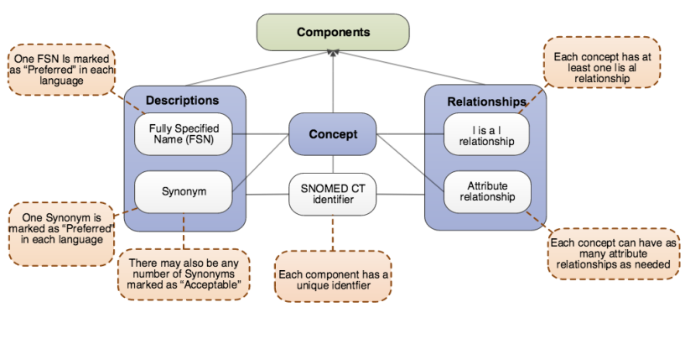

### Logical model

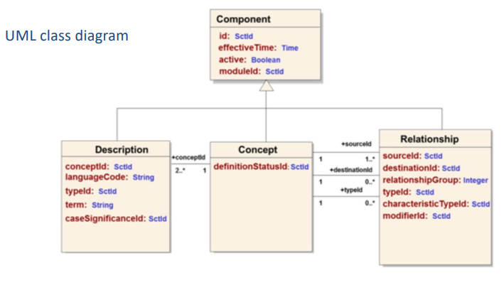

### Briefly

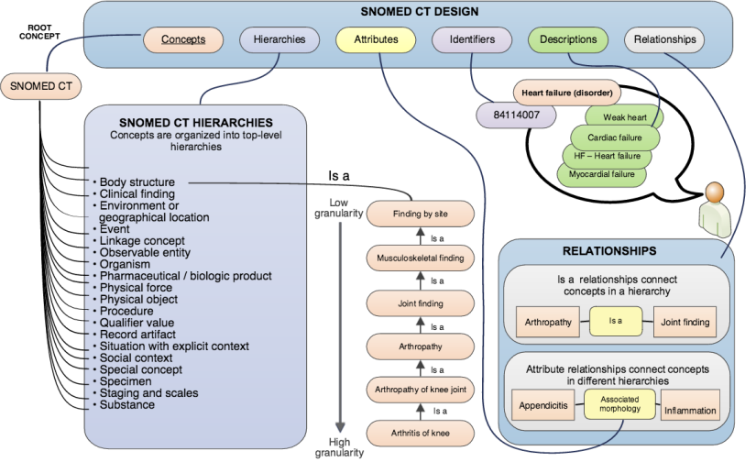

### Benefits

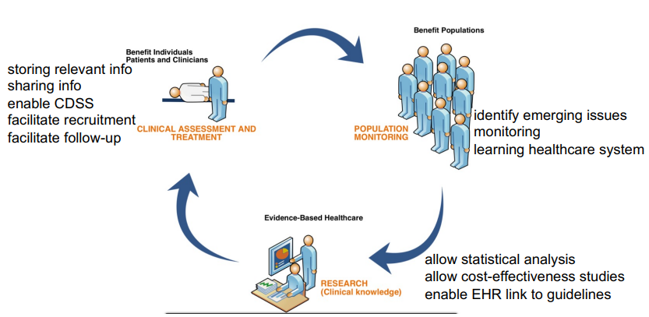

### Example - Pre-coordinated and post-coordinated terminology

#### Pre-coordinated

Single concept identifier that represents an idea. I just need the ID associated to it. E.g., 71620000 is fracure of femur. And I don’t need any other relationship, description or concepts.

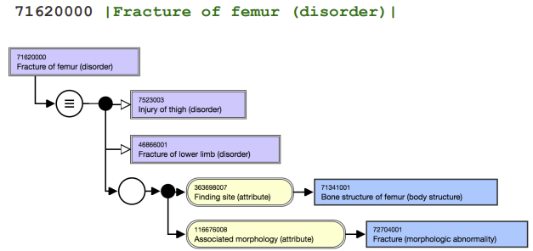

#### Post-coordinated

Two or more concept identifiers that represent an idea. I’m using more than one ID to get to the idea. E.g., I start from fracture of bone -> finding site (femur) -> fracure of femur to obtain the post coordinated expression of fracture of femur.

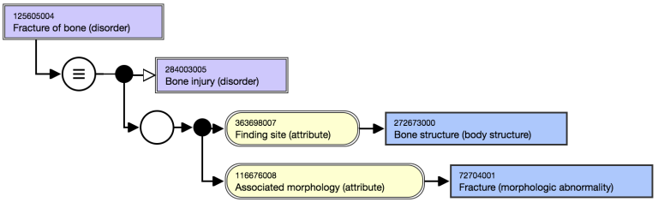

### Relationships features

Feature 1: All defined relationships of a concept must be always true for the concepts they define. For example:

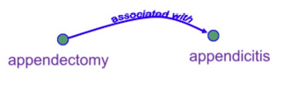This relationship is **not always** true! Removing the appendix is an appendectomy weather or not the patient has appendicitis. Thus, this relationship cannot be a defining relationship for the concept appendectomy.

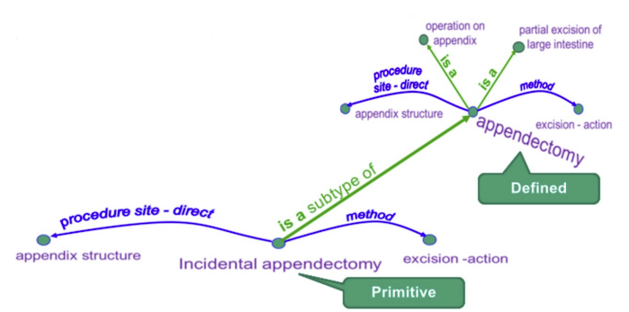Feature 2:

If the set of relationships is sufficient to define the concept à concept status = defined. If the concept status is not sufficiently defined, then it is a primitive.

# Unified Medical Language System

The main problem of terminologies is that there are too many. This happens because a terminology cannot work in all scenarios. Moreover, for geographical, ignorance, historical/political reasons some existing terminologies are not used.

Given the diversity of needs, universal terminology is unlikely to satisfy all of them.

There are many biomedical terminologies in use. Terminologies are not always freely available. Terminologies do not necessarily link to each other. Terminologies come in a variety of formats and data models.

The UMLS, or Unified Medical Language System, is a set of files and software that brings together many health and biomedical vocabularies and standards to enable **interoperability** between computer systems. So, UMLs is not a terminology per se.

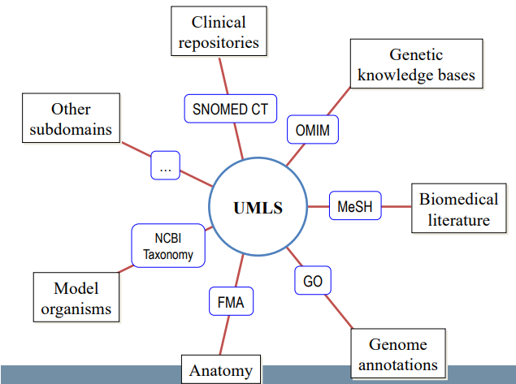It creates a high-level data model connected to all the terminologies. So, it’s powerful to retrieve information from texts where different terminologies have been used.

You can use the UMLS to enhance or develop applications, such as:

electronic health records.

classification tools.

dictionaries.

language translators.

UMLS facilitates the development of software aimed at understanding medical language.

UMLs gives us a common data model to retrieve data and information from different freely available databases and ontologies.

UMLs vs individual vocabularies

* Broader scope
* Extended coverage
* Finer granularity
* Unique identifiers. It still is an ontology.
* Synonymous terms clustered into concepts
* Additional synonyms
* Additional hierarchical relationships
* Semantic categorization

One powerful use of the UMLS is linking health information, medical terms, drug names, and billing codes across different computer systems. Some examples are:

* Linking terms and codes between your doctor, your pharmacy, and your insurance company
* Patient care coordination among several departments within a hospital
* The UMLS has many other uses, including search engine retrieval, data mining, classification, public health statistics reporting, and terminology research

## UMLs benefits

* It provides access to Terminology Data
* It provides interoperability. E.g., through synonymy
* It offers a Common Data Model for Terminologies

**Problem 1**: Terminology data is not always freely available.

Solution: National Library of Medicine (NLM) has negotiated the right to redistribute terminologies via UMLS for use in **research** before health care. Users must sign up for a free account and agree to terms of the UMLS Metathesaurus License.

3 Knowledge Sources used separately or together:

* Metathesaurus: 1 million+ biomedical concepts from over 100 sources
* Semantic network: 135 broad categories (hierarchies) and 54 relationships between categories.
* SPECIALIST Lexicon & Tools: lexical information and programs for language processing.

It is a wider version of SNOMED CT.

## Metathesaurus

* Vary in purpose, structure, and properties
* Used in clinical, research, administrative, public health reporting
* Sets of valid values:
  + Thesauri, e.g., MeSH, CRISP, NCI
  + Statistical classifications, e.g., ICD-10-CM
  + Billing codes, e.g., CPT, ABC Codes
  + Clinical coding systems, e.g., SNOMED CT
* It preserves the meaning of the different source vocabulary (same concept in different hierarchies, conflicting relationships, …)
* It is multi-purpose -> customization is needed -> MetamorphoSys. Customization to improve your own algorithm execution.

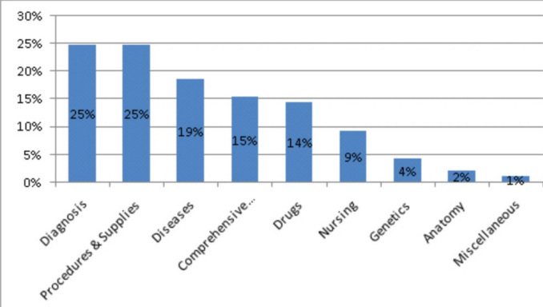

Methatesaurus clusters terms by meaning. Each concept has synonyms. Preferred term is chosen, and a unique identifier (CUI) is assigned. CUI has no intrinsic mean. UMLS links to the definition of the terminology (e.g., chosen from SNOMED CT):

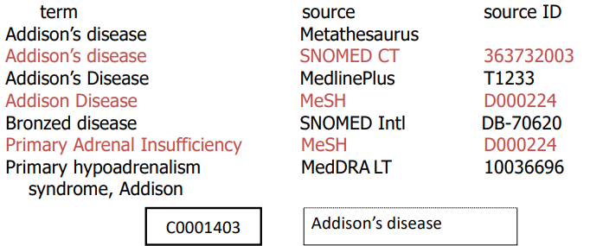

If UMLS has chosen the preferred term from SNOMED-CT, its CUI is linked to the definition contained in SNOMED CT.

**Problem 2**: Terminologies are too many and not always linked to each other.

Solution: UMLS asserts synonymy by grouping names from different terminologies into concepts. This can be used as a starting point for crosswalking from one terminology to another. The Atom identifier is the ID assigned by metathesaurus to link to the terminology of the original source.

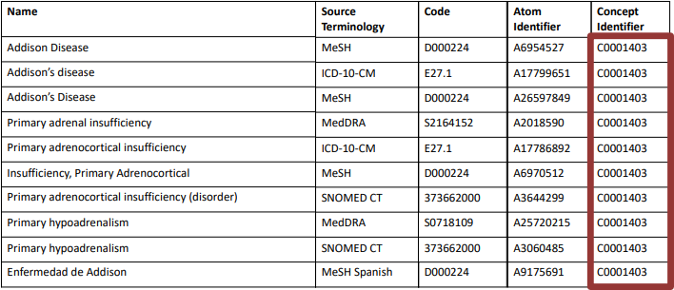

**Concept Unique Identifiers (CUI)**: a concept is a meaning. A meaning can have many different names. A key goal of Metathesaurus construction is to understand the intended meaning of each name in each source vocabulary and to link all the names from all the source vocabularies that mean the same thing (the synonyms). CUI contains the letter C followed by 7 numbers.

**Lexical (term) Unique Identifiers (LUI)**: LUI links strings that are lexical variants. Lexical variants are detected using the Lexical Variant Generator (LVG) program, one of the UMLS lexical tools. LUI contains the letter L followed by 7 numbers.

**String Unique Identifiers (SUI):** each unique concept name or string in each language in the Metathesaurus has a unique and permanent string identifier (SUI). Any variation in character set, upper-lower case, or punctuation difference is a separate string, with a separate SUI. SUI contains the letter S followed by 7 numbers.

**Atom Unique Identifiers (AUI)**: the basic building blocks or "atoms" from which the Metathesaurus is constructed are the concept names or strings from each of the source vocabularies. Every occurrence of a string in each source vocabulary is assigned a unique atom identifier (AUI). If the same string appears multiple times in the same vocabulary, for example as an alternate name for different concepts, a unique AUI is assigned for each occurrence. AUI contains the letter A followed by 7 numbers.

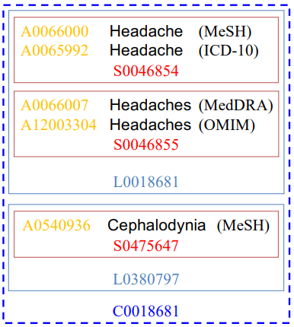Atom identifiers in yellow. The string headache has the red identifier. It is a synonym of headaches that has another string ID. But they both shares the same lexical identifier (light blue). Cephalodynia is a synonym, but it is completely another string. But UMLS gather all this IDs inside the unique CUI (blue) identifier.

**Each CUI (concept) is linked to at least one AUI (atom), one SUI (string), and one LUI (term).**

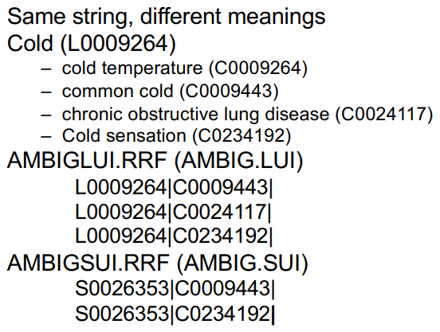UMLs also represents ambiguity:

**Problem 3**: Terminology data is represented in a variety of formats according to a variety of data models.

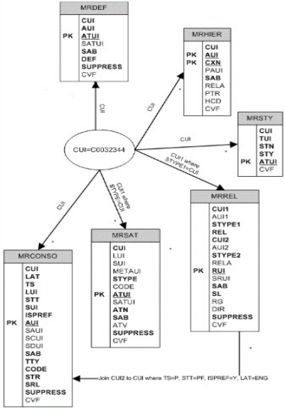Solution: The UMLS represents all terminology data according to a standard data model.

## Semantic Network

The semantic type of addison’s disease is disease. The category of a concepts is the semantic type.

A **semantic type** is a high-level category assigned to concepts. Semantic types are divided into:

* Entity
* Event

Entity and Event are the highest semantic types.

Examples of Entity semantic types are:

* Medical Device
* Gene or Genome
* Carbohydrate

Examples of Event semantic types are:

* Social Behavior
* Laboratory Procedure
* Mental Process

**Semantic relationships** are links between categories.

Some examples of the 'isa' relationship:

* Animal isa Entity
* Carbohydrate isa Chemical
* Human isa Mammal

There are five major, non-hierarchical relationships:

* Physically related to
* Spatially related to
* Temporally related to
* Functionally related to
* Conceptually related to

Relationships may or may not hold at the concept level. The relations are stated between high level semantic types in the Network whenever possible and are generally inherited via the "isa" link by all the children of those types.

Example: the relation "evaluation of" holds between the semantic types "Sign" and "Organism Attribute", but it does not hold between any particular pair of concepts (that are children of Sign and Organism type). Signs such as "overweight" and "fever" are evaluations of the Organism Attributes "body weight" and "body temperature", respectively. However, "overweight" is not an evaluation of "body temperature", and "fever" is not an evaluation of "body weight”.

Granularity varies across the Semantic Network

The node Manufactured Object has only 3 child nodes: - Medical Devices - Research Devices - Clinical Drug. There are manufactured objects other than these 3. Rather than proliferate the number of semantic types to encompass multiple additional subcategories for these objects, concepts that are not medical devices, research devices or clinical drug are simply assigned the more general semantic type "Manufactured Object".

The level of granularity varies a lot according to the semantic type we are referring to (disease has a high degree of granularity because a lot of terminologies include diseases)

#### Morphology example

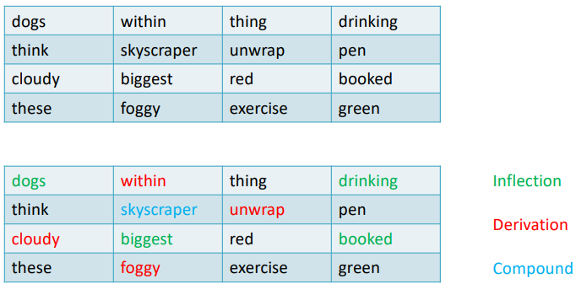

## SPECIALIST Lexicon

It is intended to be a general Syntactic English lexicon of common words, biomedical terms (330K+ words, 550K+ variants). We want to analyze common words also if they only are lexical variants.

It provides the syntactic, morphological, and orthographic information needed by the SPECIALIST Natural Language Processing System to process text and terms.

Some linguistic properties:

* Syntax = the way words are used to form phrases (how words are put together)
* Morphology = the structure of words (inflection, derivation, and compounding)
  + Inflection: plural singular; verb tens; comparative superlative
  + Derivation: prefix and suffixes that produce new words with meaning or categories different from its base
  + Compound: compounding occurs when two or more words are joined to make one longer word
* Orthography (spelling)

The string identifier and lexical identifiers are the IDs that are linked to inflections, derivations and compounds.

### Lexical Entry

There is one lexical entry for each spelling or set of spelling variants in a particular part of speech.

Each lexical record contains information on:

* Base form of the term (singular for nouns, infinitive for verbs)
* The part of speech
* A unique identifier
* Rules for spelling variants

The lexicon recognizes 11 parts of speech: Verbs, Nouns, Adjectives, Adverbs, Modals, Pronouns, Prepositions, Auxiliaries, Conjunctions, Complementizers, Determiners. Approximately 86% of the entries are nouns.

The unit lexical record is a frame structure consisting of slots and fillers delimited by brackets { }. **Example**:

{base=anesthetic spelling_variant=anaesthetic entry=E0354094 cat=noun variants=reg variants=uncount}

{base=anesthetic spelling_variant=anaesthetic entry=E0330019 cat=adj variants=inv position=attrib(3) position=pred stative}

The "entry=" contains as filler the unique identifier (EUI) of the record slot. Lexical entries are **not divided into meanings**. Thus, an entry represents a spelling-category pairing regardless of semantics (e.g., Act).

When different senses have different syntactic behavior, codes for each behaviour are recorded in a single entry.

## Lexical Tools

The Lexical Tools package consists of 3 primary programs: a normalizer, a word index generator, and a lexical variant generator.

**Normalization** (a selection of LVG transformations): stripping possessives, replacing punctuation with spaces, removing stop words, lower-casing each word, breaking a string into its constituent words, and sorting the words in alphabetic order. It produces normalized word and string indexes (MRXNW & MRXNS) example:

**In**: Abnormal, weight, gain **Out**: abnormal gain weight

It is used to find similar terms, map terms to UMLS concepts and find variants.

* Word index (Wordind)
  + breaks strings into words
  + produces the Metathesaurus word indexes (MRXW)
* Lexical Variant Generation (LVG)
  + performs various lexical transformations of input words

### UMLS users and uses

Researchers, Health application developers, Health service providers, …

Used for clinical systems, clinical research, protocols, …

## Importance of UMLs

Why it is important to identify meaning from text?

* Because medical data in the real world is often unstructured (e.g., clinical notes or the biomedical literature/ abstracts).
* To improve search and retrieval by annotating records in a research database.
* To find co-occurrences of concepts in text.
* To annotate clinical text on the fly.
* To identify a patient population.

**UMLS provide tools for NPL!**

# Natural Language Processing

Natural Language Processing (NLP) is a range of computational techniques for analyzing and representing naturally occurring texts at one or more levels of linguistic analysis for the purpose of achieving human-like language processing for a range of tasks or applications. In other words, NLP is needed to transform relevant information hidden in unstructured text into structured data that it can be used by computer processes.

The goal is not only to retrieve specific words in unstructured text, but to find concepts and understand relations among them, simulating the human capability to understand the language.

NPL allows the extraction of semantic information from text. Some Possible Applications:

* Information extraction (e.g., biosurveillance such as symptoms extraction, pharmacovigilance to identify adverse events) reliability increases if modifiers of interest are also identified and if some reference resolution is used…
* Semantic Information retrieval (concept based).
* Question answering.
* Automatic summarization (generic or query-focused).
* Text generation (from DB to natural language to sum up data trends).
* Document classification.
* Automatic translation.

## Why NLP is possible?

Because natural language is formulaic: it contains discrete symbols (words) and rules (grammar) specifying how different elements can be combined to define a phrase with a specific meaning. Thus, patterns of language structures can be found in text. To obtain NLP algorithms, knowledge on language should be integrated with knowledge on a specific domain to automatically analyse a text.

## Linguistic knowledge

Linguistic knowledge consists of different levels:

* morphology: combination of different morphemes (root, prefixes,suffixes) to produce lexemes (words).
* syntax: structure of sentences (grammar) and lexicon.
* semantics: meaning of words and phrases.
* pragmatics: intent of the speaker/context.
* discourse: paragraphs, coreference between paragraphs.

The big issue is that humans can understand words meaning based on the context. Is it not always possible with NLP.

## NLP is a complex task

1. Named entity recognition:
   1. Linguistic variations: different words with the same meaning (hepathic, or of the liver).
   2. Polysemy: one word with multiple meanings (left, it is both a verb and an attribute).
2. Contextual attribute assignment:
   1. Negation: approximately half of all clinical concepts in clinical reports are negated. E.g., “the kidney is not enlarged” is a a negative sentence with a positive meaning.
   2. Uncertainty: treated for a presumptive sinusitis.
   3. Temporality: in the past the patient suffered from hepatic steatosis.
3. Discourse processing:
   1. Report structure: well defined sections help NLP: e.g., medications mentioned in medication sections are prescribed while if they are in the allergy section they should not be prescribed.
   2. Co-reference: sentence starting with pronouns, to what/who are they referred?

## How NLP method works

The different approaches to NLP can be grouped into different categories:

1. Statistical focused approach.
2. Linguistic focused approach.
3. Machine learning.
4. Hybrid approaches, e.g., statistical-linguistic approach.

Typical NLP pipeline:

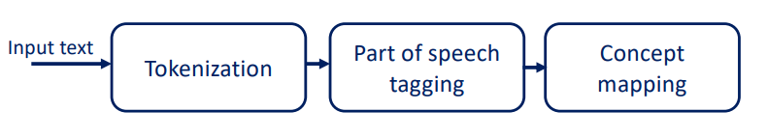

Each concept is mapped to a specific vocabulary. We need one!

## Metamap

MetaMap is a highly configurable program developed at the National Library of Medicine (NLM) to map biomedical text to the UMLS Metathesaurus or, equivalently, to discover Metathesaurus concepts referred to in text.

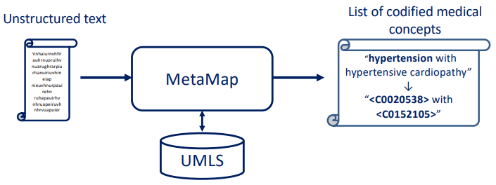

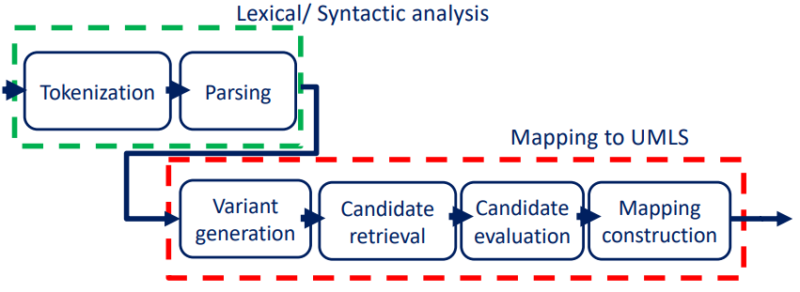

Candidate retrieval -> generating possible evaluation of the text. **All the candidates are part of the ontology.**

Tokenization: boundaries of sentences, acronym/abbreviation identification, part-of-speech tagging (name-entity step. Using lexical entries to understand if the word is a noun an adjective, a verb, …), identification of simple noun phrase.

**Variant generator**: the MetaMap generation of variants is useful to consider textual variations (derivational variants, acronyms and abbreviations, synonyms). The variants generation starts from each meaningful sequence of word in the phrase. E.g., low-protein diet--> low-protein diet, low-protein, low, protein, diet.

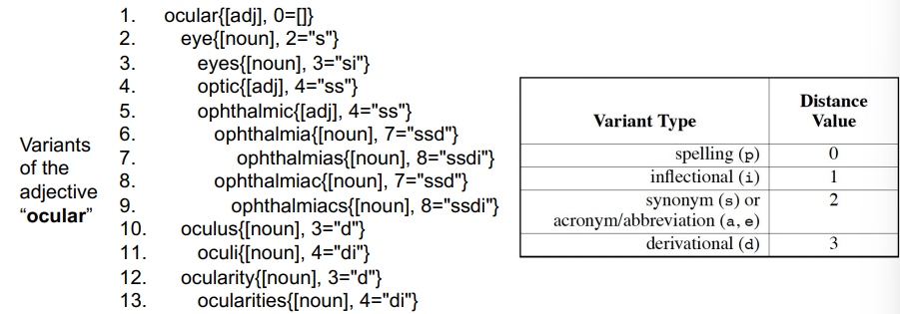

How distant is a variant from its base?

**Candidate evaluation**: The evaluation function computes a measure of the quality of the match between a phrase and a candidate, considering 4 linguistic inspired features:

* centrality (the candidate contains the “head”?) For the noun phrase ocular complications, Complications has centrality value 1; and Eye (ocular) has value 0.
* variation (V) (how much the variants in the candidate string differ from the corresponding words in the phrase?):
* Di=distance for each term (e.g., spelling 0; inflectional 1; synonim 2; derivational 3)
* Vi =4/(Di +4) ; V=mean(Vi)
* coverage (how much of the text is matched?)
* cohesiveness (like coverage, but emphasizes the importance of connected components (i.e., the sequence of contiguous words)

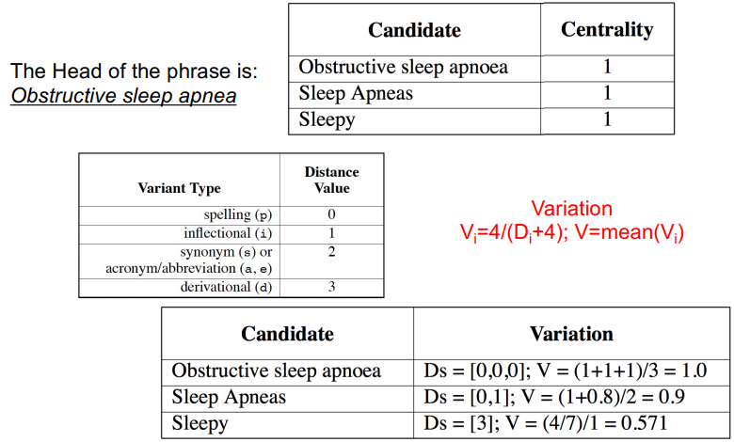

In this case spelling has distance 0. So, apnea and apnoea are considered as the same.

* Phrase span = number of words of the phrase involved in the match.
* Candidate span = number of words of the candidate involved in the match.
* Coverage = $\frac{\text{phrase span}}{\#\text{words in the phrase}}+2⋅\frac{\text{candidate span}}{\#\text{words in the candidate}}$

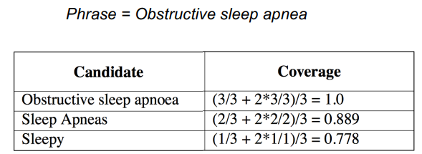

Connective component = maximum # of contiguous words participating in the match

Candidate span = number of words of the candidate involved in the match

Cohesiveness = $\frac{\text{phrase connective }{\text{components}}^{2}}{\#\text{words in the }{\text{phrase}}^{2}}+2⋅\frac{\text{candidate connective }{\text{components}}^{2}}{\#\text{words in the }{\text{candidate}}^{2}}$

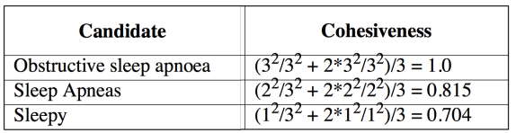

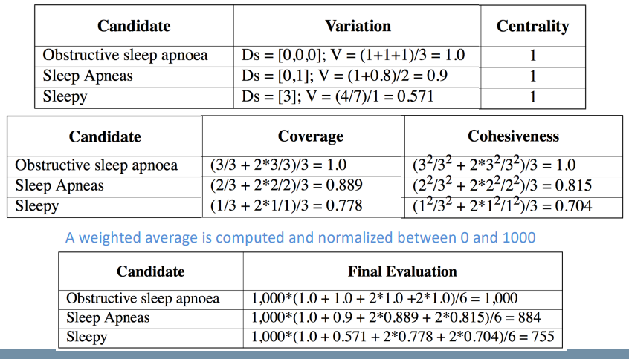

#### Mapping example:

In mapping construction, candidates found in the previous steps are combined and evaluated to produce a final result that best matches the phrase text.

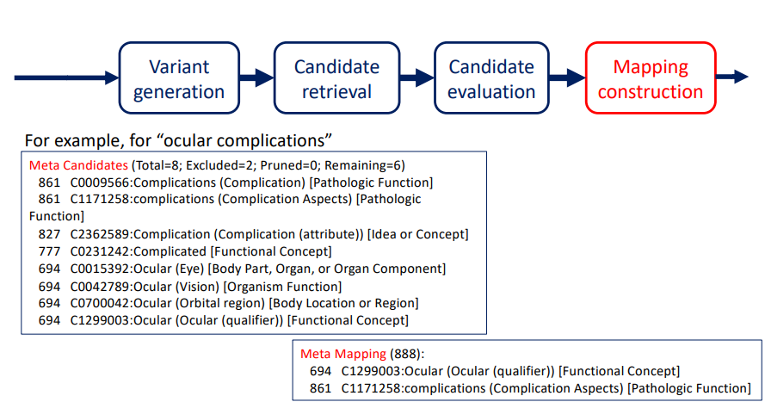

In conclusion, what we are doing with MetaMap algorithm is:

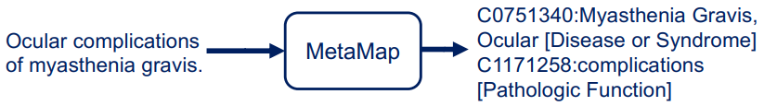

We extracted health-related information from unstructured text and transform it into structured data that can be used by other computer processes.

# Methodology to design, develop and evaluate e-health technologies

The essence of healthcare is to provide the best care possible that meets the needs of patients and their caregivers. Nowadays informal caregivers and empowered patients are more in the lead of their care. We are moving to a cooperative healthcare in which all actors are actively involved in the process. Technology is needed to support this change in the process.

It is ismportant that **all the actors** are **involved in the development** of an e-health application.

We can categorize eHealth technologies according to:

* their place in healthcare:
  + 1. Services to support care delivery (diagnostics, therapy, treatment, …).
    2. Services to manage care (personal health records, portals, ...).
    3. Services to promote prevention and education.
* their main aim: to monitor people and to develop tailored and personalized health interventions (e.g., domotics, wearable devices, virtual reality, personal health records or web-based applications).
* their influence on the healthcare system: describing the infrastructure for healthcare, emphasizing the possibilities to innovate or disrupt healthcare (e.g., decision support systems).

Among the various e-health technologies (e.g., headbands, sociometric badges, camera clips, smartwatches, sensors ambedded in clothing, …) we have also coaching apps. Here, for example in a diet coaching app, it is important that a nutritionist has been involved in the development.

## Acceptance, Adoption and Adherence: 3 challenges

A technology is accepted if the requirements meet the stakeholders needs.

Adoption means to use the technology but also something that enters in the routine of the user. Adoption problems due to:

* Lack of communications and coordination between all stakeholders.
* Marginal level of user engagement.
* Solutions not integrated in the daily routine.

## System development

The traditional way to develop a software was sequential: requirements, design, implementation, verification, and mainteinance.

This nature is rigid. Changing requirements can be difficult when already in the design/implementation phase. Spiral models were suggested adding iterative cycles to the sequential phases.

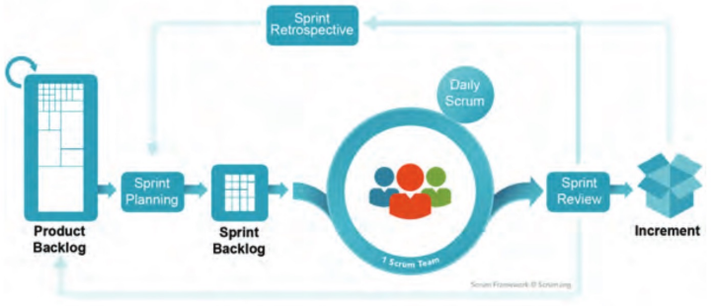

It is difficult to specify all requirements in advance (too many stakeholders involved). This spiral model is more flexible and faster to react to changes).

## Proposed Solution

A holistic approach for e-health design and evaluation:

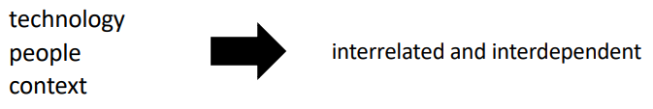

### Design principles

* should be participatory, stakeholders’ involvement is crucial. For a serious game for children the stakeholders are children, parents, teachers, clinicians, school offices.
* should be iterative (involving continuous evaluation cycles to refine development). At each step of development, I’ll ask stakeholders to test each new functionality.
* should include pervasive design techniques to facilitate adoption and to induce behavioural change.
* should define evaluation methodologies from the beginning (RCT are not well suited for it because technologies change very fast).

Among the stakeholders we can also find insurances, or government (to reach all the schools for a children technology, for example).

### Multidisciplinary development team

The team needs experts in:

* design
* implementation
* evaluation

that are responsible for producing technology, but it does not mean that they are experts of the domain.

The team also needs experts of the application context:

* health professionals
* target users
* caregivers
* …

that are responsible for assuring that the technology fits in with needs and values.

### CeHres roadmap

A guideline for eHealth development, implementation and evaluation developed by the University of Twente.

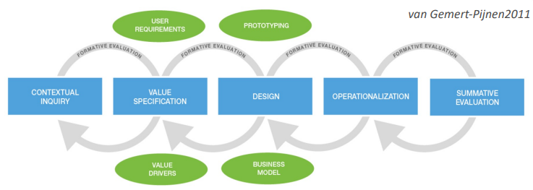

#### Contextual Inquiry

Aim: To get a thorough understanding of the users, stakeholders, and environment.

Outcome: to have an overview of the current situation, the rules, regulations and ethical issues of the context, and the possibilities and conditions for the use of technology.

There are different methodologies that are inside the contextual inquiry that are suggested, and we may decide to use one or not, it is not compulsory that we follow all the steps, we can choose according to the specific aim we have.

1. The first one is a must, which is **stakeholder identification**. So, it means identification of the people who are affected by an e-Health technology. This step is fundamental.
2. The second step is **stakeholder analysis**, which means understanding which stakeholder is responsible for what, what is its role, how it is affected by the technology and why we need to speak with one stakeholder rather than another. In other words, it means the analysis of interdependencies, responsibilities, and stakes of involved stakeholders. The first stakeholder list is very broad, then, by analyzing them, we start giving priorities and choosing the most important and significant case by case.
3. The third step is **desk research**, which is a non-systematic collection of material. It is just to understand as much as possible the context, it is more a research about the main products that are used, the main things that are done. This step is not that relevant, but it depends on the context (for instance, if we are ding something for social channels it is very important, because we are not finding a lot of literature about that).
4. The fourth step is the **scoping review**, which is the gaining of insights in the status quo of the scientific literature in a certain broad field of study by means of a systematic search of the literature. As technicians we should have in mind what was done and what was researched about the topic we are dealing with.
5. The fifth step is **focus group**. Focus groups are small meeting, devoted to a little group of stakeholders of the same kind. We will not find one doctor, one parent, one child and one technician at the same table, it has to be done separately with stakeholders of the same kind to interview them and drive the discussion in a way that we can get valid requirements for that set of stakeholders. For instance, by interviewing teachers we can understand that children, when they start writing, they are using not a pen but a pencil. This could be useful for example to prevent dysgraphia. Dysgraphia is discovered from the third class of elementary school, when children use pens. So, a possible solution could be to find an erasable ink. Focus groups are very much used in the medical sector, and there should be a mediator that really drives the discussion towards the main relevant questions for the aim. We cannot organize a focus group without a clear plan in mind.
6. The sixth step are **interviews**, which consist of the asking of questions in a structured, semi-structured or unstructured way to obtain answers from an individual. They can also be questionnaires that can be done in a way to reach a lot of people, not only a small group of people.
7. The seventh step is **observations (field research)**. We need to observe children attitude, for instance. we need to observe the habits. With the intended use in mind, we can understand what the best methodology is to use, taken for granted that stakeholders identification and analysis phases are a must.
8. The eighth step is **diary** **study**, which consists of keeping a diary of certain events on a regular basis by research participants, so the patient is required to keep a diary in order to understand their routines.
9. The last step is **log** **data** **analysis**, which means the use of data that logs certain behavior on a system in daily life to analyze patterns. We can allow the use of a first prototype of our product, for instance, to check how they are using it and we can also do some data mining on the percentage of use and understand if it is of value or not.

#### Value Specification

Values are the things that stakeholders would like to see reflected and improved or maintained by the eHealth technology. Speaking with stakeholders we buil a table with:

* GAINS – benefits, needs
* PAINS – negative experiences, risks
* CUSTOMER JOBS – task customers are trying to perform, wishes that are provided in the product.

Example of customer profile for an app for stress relief:

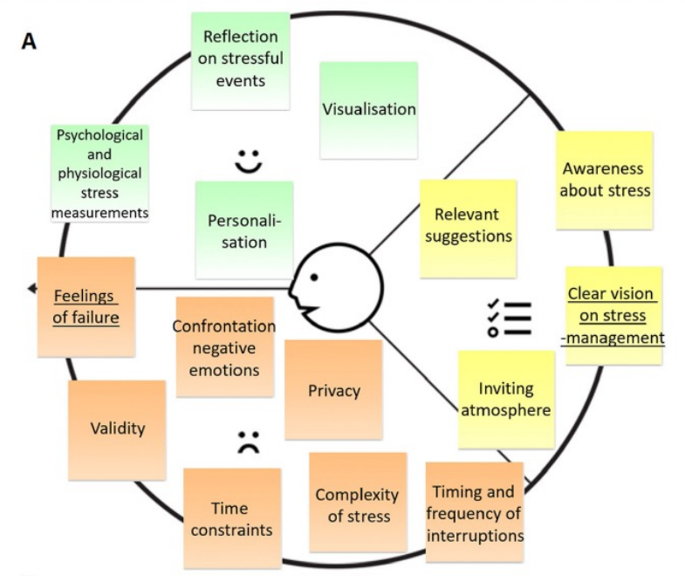

Form the customer profile we can go to an additional dashboard which is called Value Proposition, that shows how the product creates value for the customer. Values are the things that stakeholders would like to see reflected and improved or maintained by the eHealth technology.

* GAINS CREATORS – how the product creates gains
* PAIN RELIEVERS – how the product alleviates pains
* PRODUCT AND SERVICES – what the product provides

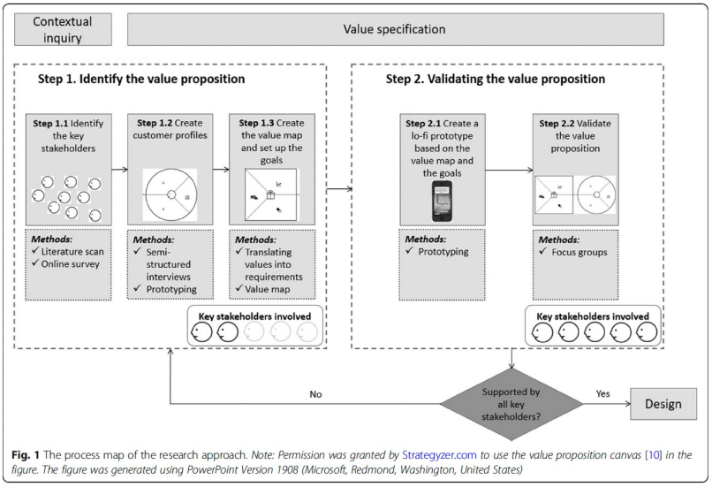

#### Design

The design phase mainly consists in building prototypes responding to requirements.

1. From functional to technical requirements.
2. Both low-fidelity (lo-fi) and high-fidelity (hi-fi) prototypes.
3. Usability tests of prototypes with end-users, experts, and stakeholders in real life environment.
4. Testing phases with feeback to refine requirements.

### Requirements development approach

Requirements are the building block of the whole design and development process. They define, for instance:

* What the technology should do (functionalities).
* What data should be managed.
* Interfaces and what to display.
* What is the expected user experience.
* …

Requirements definition is a process normally left to engineers but there should be a multidisciplinary team of stakeholders involved in their definition and refinement.

* **Content** requirements: these requirements specify what information the technology should manage and present to the user.
* **Usability** and **user** **experience** requirements. These requirements concern the user perspective and specify the interface and interaction design of the technology.
* **Functional** and **modality** requirements. These requirements specify technical features and prescribe the kind of technology and operating systems. They are mainly focused on the programmer’s point of view (e.g IOs and/or Android).
* **Service** requirements. These requirements state the best way to organize the services that support the user.
* **Organizational** requirements. These requirements concern the integration of the technology into the organizational structure and working routines.
* **Technical** requirements. These requirements concern the hardware and software specifications needed.

Requirement development approach is based on 5 phases that are orthogonal to the ceHres roadmap:

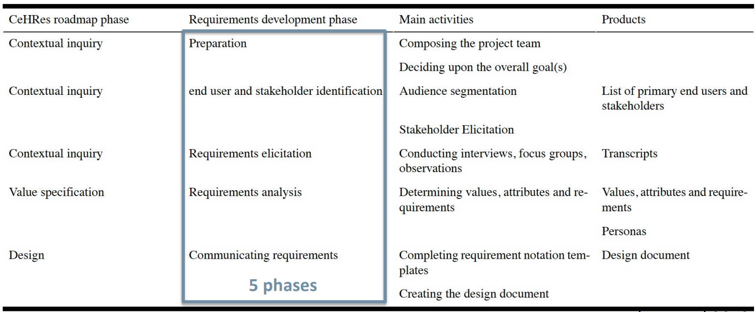

#### Design - Prototypes

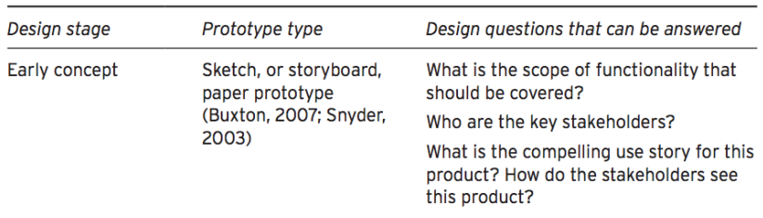

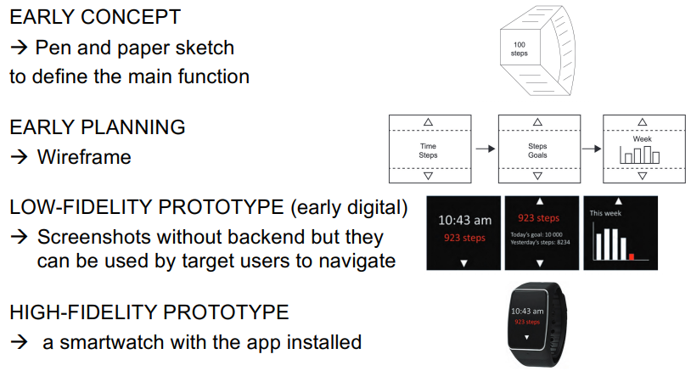

#### Operationalization & Summative Evaluation

OPERATIONALIZATION:

* Create a plan to make sure that the technology is introduced and used in pract9ice in the long term.
* Determine concrete activities to implement the eHealth technology in practice.
* Launch the final version of the technology in practice mobilizing also additional support (user support) -> FIRST REAL FIELD TESTING.

SUMMATIVE EVALUATION

* Determining the impact of the technology.
* Analyzing the uptake of an eHealth technology in terms of adoption or use of the technology by predetermined users and implementation, and use within the intended context.

FORMATIVE EVALUATION is the backbone of development (the gray circles in the CeHres roadmap. It makes development **iterative**. It is used to identify potential implementation problems and tackle them in early phases of development.

EVALUATION METHODS

With experts:

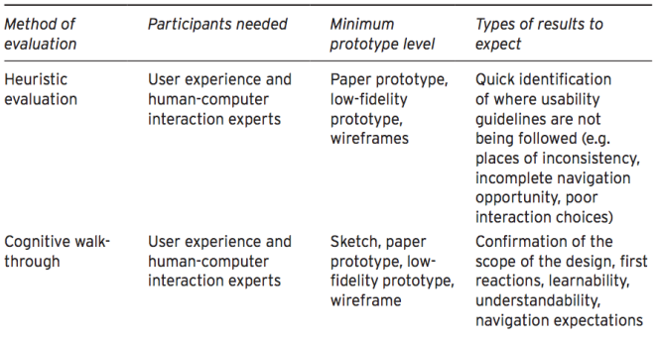

With target users:

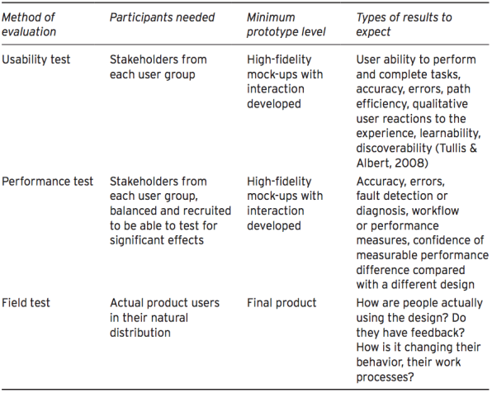

There are two things to keep in mind. First, testing can also involve experts and stakeholders that are not the target users. There are *heuristic evaluation* methods and *cognitive walk-through* evaluation methods that are the interaction between both low-fidelity prototypes and high-fidelity prototypes with experts, to understand if what we are proposing responds to the guidelines, and to the needs of the patients. So, we can use these evaluation methods with experts during the development process to understand if we are going in the right direction.

Then, we test evaluation methods with target users, which are *usability test* evaluation, *performance test* evaluation, and *field test* evaluation. Performance is more linked to the functional evaluation, so it evaluates if the device is doing properly the task it was intended to perform. It is a technical test. Instead, field test is a daily-life test to assess adoption. Usability test is more a quality assessment, so it assesses if the device is usable/easy to use, if it is perceived as something that can be adopted. Usability is more subjective and made on qualitative questionnaires, while for the other tests we can collect data for quantitative evaluations of the performances and on the field test.

# Methods to evaluate novel e-health solutions

Let’s start from an example: to evaluate motor behaviour of children (and people in general) optoelectronic systems are the gold standard. However, it is an ingombrant system that can produce biased data (e.g., not-normal walking, limited space due to wires, controlled space and not normal environment).

We need some tools to evaluate motor behaviour in a non-protected environment. A new e-Health tool could be very useful.

Another example: suropsychological tests need an expert supervision. So, remote use is not possible.

We need new technological solutions:

* Domestic use (not only in clinic). We could accept little less reliability in exchange of real-time monitoring.
* Not bulky to allow a physiological and natural gesture.
* Easy to use. This can be evaluated also during the evaluation process.
* NO/reduced supervision of an expert. Software intelligent enough to reproduce some sort of supervision to increase reliability.

Given new technological solution we need a validation process. New solutions require both verification and validation, which are two processes that together indicate whether a digital measurement tool is fit-for-purpose. These processes involve two groups of experts, both engineers (verification) and clinician lead (validation).

**Error:** total measurement error is the result of systematic error, which affects validity, and random error, which affects reliability. The error affects the real value:

$$\text{Measured value}=\text{Real value}+\text{Total Error of measurement}$$

The systematic error affects the measurement in a particular direction. The random error leads to inaccurate measurement in unpredictable ways. Mean and median are affected only by systematic errors while variability by random ones.

**Reliability:** how coherently a method measures what it is intended to measure.

**Validity:** How accurately a method measures what it is intended to measure.

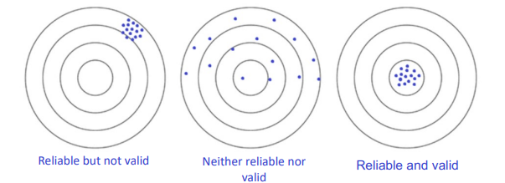

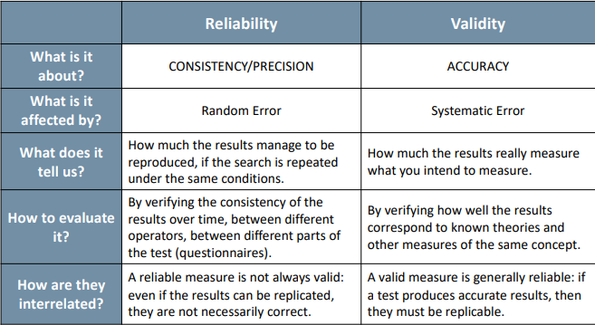

## Reliability

Reliability is extremely important in clinic, for instance, if we need to measure something pre and post treatment, we need to know how much that measurement can be reproducible.

Types of reliability:

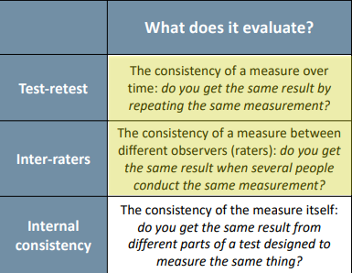**Test-retest**: “within observer reliability”. Remind that it could be affected by intra-individual variability, so it is important to choice the sample a priori and also the interval between measurement (e.g., oxygen measurement during exercise. Is the subject already tired?).

**Inter-raters**: “concordance”. Level of standardization. There is no variability due to subject evaluation during measurement.

The **internal** **consistency** evaluates the consistency of the measure itself. It applies to questionnaires.

## Validity

Types of validity:

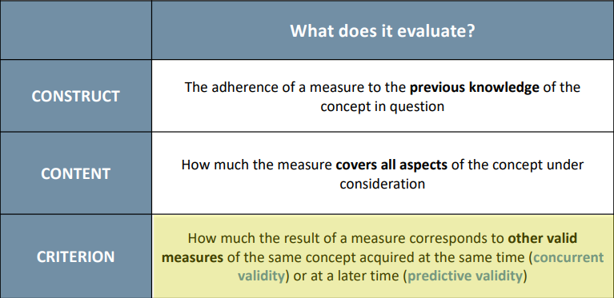**Construct:** more applicable to qualitative measurement and questionnaires.

**Content:** for example, a lot of psychological measurement are not related to an emotion-recognizer device.

**Critetion: i**t is the type of validity that we need to assess for a new tool. For example, if we create a new EMG measurement tool, we should perform measurements with two instruments at the same time, the current one and the new one, and then compare measurements.

## How to assure the reliability and validity of a new instrument

Statistical analysis can inform the choice of method by quantifying the reliability and validity in relation to the "analytical objective" (the practical requirements of the measurement tool).

Let’s distinguish absolute and relative reliability and validity:

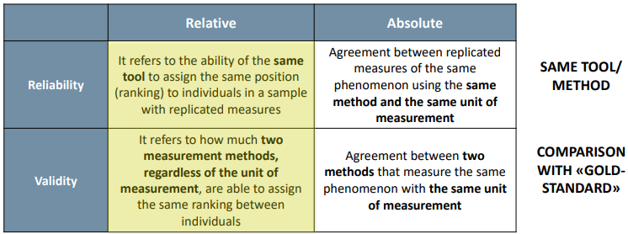

## Correlation coefficients

They measure the relation between two variables and not the agreement, so they measure **relative** reliability and validity. The two variables are obtained from repeated measurements with the same method (reliability), or with different methods (validity). They ignore the unity of measurements of the two variables, and values approaching 1 are interpreted as high validity or reliability.

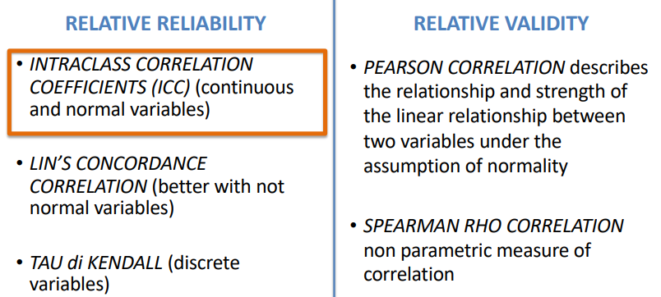

**Intraclass Correlation Coefficients (ICC)** is a sort of correlation analysis but for repeated measures, and it is applied to continuous and normal variables only (parametric statistical approach). This means that we are doing the test-retest, but we are in the case in which we are assessing the relative reliability by using only our tool. So, the relative reliability is computed by using this coefficient, which varies between 0 and 1, where 1 means “reliable” and 0 means “not reliable”. The result is not in absolute terms.

The equivalent of the ICC for variables that are not normally distributed is called **Lin’s Concordance Correlation**, and when the variables are dichotomic we use the **Tau di Kendall**

### Interclass Correlation Coefficients

We need to know what the stability of our measurement in test-retest is or in inter-rater reliability, and we need to analyze the results. So, we have already done all the measurements and we want to see if this measurement is reliable. Given that the ICC represents different concepts, the workflow in the figure, represents a way to choose which model of the ICC is best to be used.

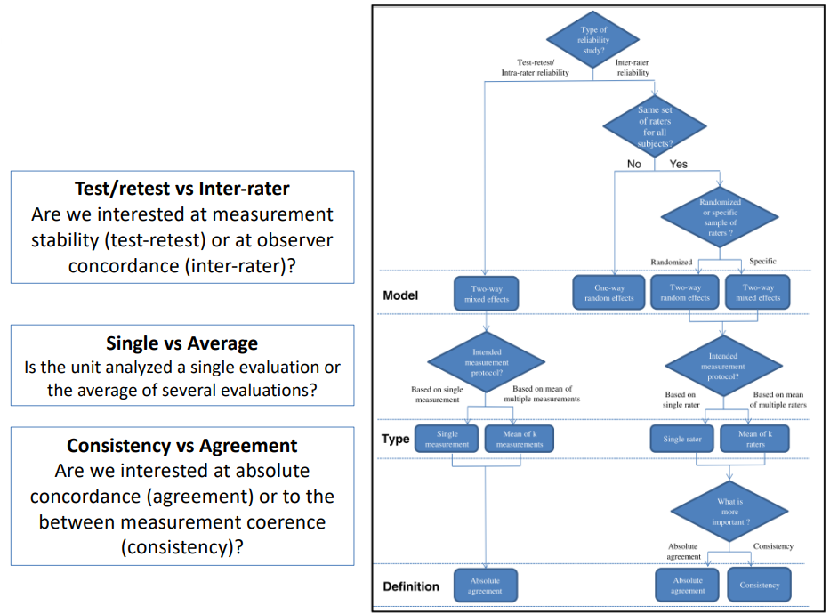

This workflow allows us to choose the best model to use. According to it, at the end we will have a reliability that varies between 0 and 1. If we get 1, it means that our measurement is reliable.

### Relative validity

If we need to measure validity, the only way to understand if there is relative validity between two measurements is to do a sort of simple correlation analysis. We correlate the two measurements to understand if their trends are the same. We cannot evaluate the absolute value, so we just evaluate if the trend of the measurements is the same. So, we have Pearson correlation, which describes the relationship and strength of the linear relationship between two variables under the assumption of normality, and Spearman Rho correlation, which is a nonparametric measure of correlation. So, we have one or the other depending on if the variable is normally distributed or not. Relative validity is weak, but if it is the only thing we can do, we do this correlation analysis.

## Band-Altman Plot

If we are speaking about ABSOLUTE MEASUREMENT, we speak about the Bland-Altman Plot, which is a way to visualize the goodness of a new measurement tool compared to the Gold Standard, in absolute terms.

The difference with correlation coefficients is shown in the following table:

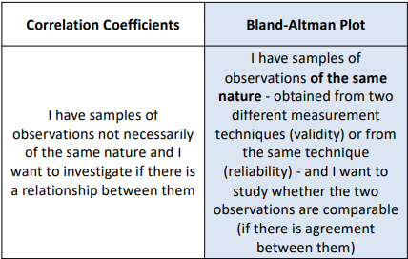

The Bland-Altman plot is used to compare two measures of the same nature. It is a dispersion diagram (X1, X2), and the average of the differences allows you to estimate whether one of the two series of observations underestimates or overestimates the index compared to the other, while the other two lines constitute the confidence interval.

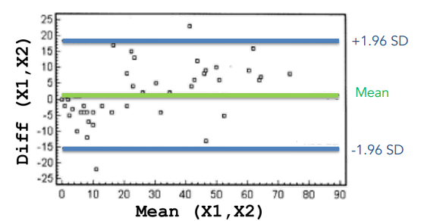

If the points in the graph are within the two lines, it is considered that the two series of observations provide congruent results, while the points outside the two lines are cases in which the two series of observations are not congruent with each other. The green line represents the Mean error, so if there is a systematic error between two instruments it means that this line is far away from 0. The two blue lines, indicated as +1.96 SD and -1.96 SD, represent the confidence intervals, so all the points inside the range between these two lines represent a good measurement. Instead, if we have a lot of outliers, visually is not a good measurement.

We can do this for both validity and reliability. To test validity, we can do it on all healthy subjects, e.g., by randomly choosing 20 healthy subjects and asking them to use the two instruments. So, for each subject (measurement) we compute the difference between the two instruments against the mean. To test reliability, we ask to the same subject to do with one instrument all the measurement on all the subjects and we can anyway use the Bland Altman plot. Example:

* We can qualitatively verify the validity of the measurements against those made by a standard thermometer. We perform the measurements for example on 20 subjects measuring the axillary temperature (temperature ascellare) with both thermometers in a very short time and then we compare the two measurements with the Bland Altman plot.
* We can qualitatively verify the reliability of the measurements of our new thermometer by making two repeated measurements with the thermometer on all 20 subjects. At that point we can do the Bland Altman between the two repeated measurements.

Researcher's judgment: if the variation of the mean within the confidence interval is not clinically important, the two methods can be considered interchangeable. The significance is not provided by statistical calculations but consists in the comparison of the two limits (upper and lower) with the clinically acceptable difference between two methods.

Bland-Altman plot also allow to understand the goodness of our measurement in other terms. For instance, let us look the following plots:

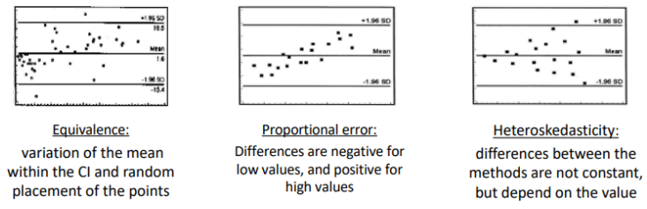

Bland-Altman plot allows us to visually understand (not quantitatively) and give us the perception about our measurement tool with respect to the Gold Standard.

In the second and third plots there are trends behavior. For instance, in the second plot we see that the error between the two measurements is proportional to the mean value of the measurement. This is because samples on the left are underestimating the Gold Standard, while samples on the right are overestimating the Gold Standard. In the third graph, the error increases with the dimension of the measurement we are doing (both positively and negatively). In this case we speak about heteroskedasticity, so when the differences between the methods are no constant but depend on the value of the measurement. The first graph, instead, represent the case where we do not see a lot of trends. We observe the variation of the mean within the confidence intervals and random placement of the points.

## Sum-Up on relative/absolute reliability/validity

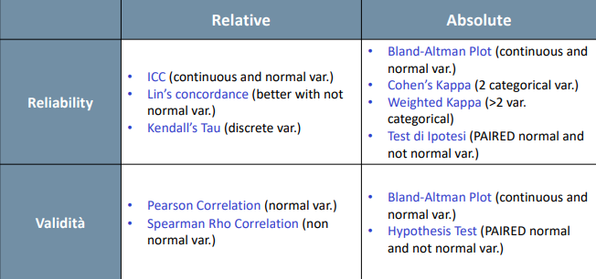

## Sample Size

The important step, anyway, is to establish how may people we need to enroll every time, so the sample size. We understood that depending on the context and on the measuring tool we have to evaluate if we can/need to do reliability or validity analysis, but on which sample?

It is necessary to calculate the sample size (A PRIORI!) to ensure that the number of subjects involved in the study allows us to adequately answer the question of interest, considering that:

* a small study will have reduced sensitivity.
* an oversized study is economically burdensome and risks subjecting an excessive number of subjects to an ineffective treatment.

There are reference tables and/or online software that help us define our sample size depending on the type of study.

## Comparison with clinical scales

We now see what happens when a Gold Standard does not exist, so when the Gold Standard is not another measurement tool, but it is just a clinical scale. We need to perform a comparison of the obtained results with the clinical scale. In this case, the comparison can be done with correlation analysis, because for sure there will not be the same unit of measurement, so it is only relative comparison and not an absolute comparison.

### Usability satisfaction and acceptance

The other concept that we may evaluate are usability satisfaction and acceptance. To do so questionnaires are used

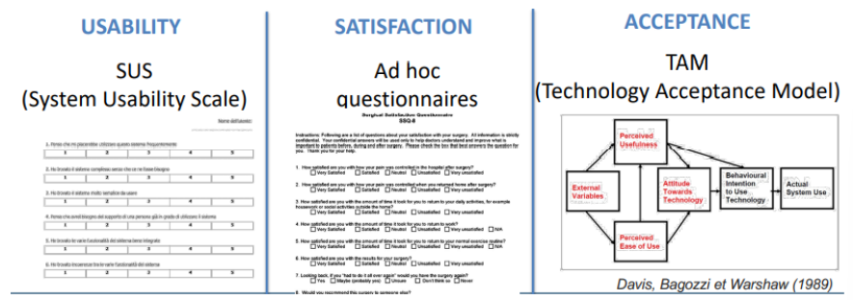

There is the so-called SUS (System Usability Scale) to assess usability. For satisfaction there are only ad hoc questionnaires that we are creating depending on the situation, because for sure it depends on what we are asking the patients to do when using our device. There is not a standard questionnaire to assess satisfaction. Instead, for acceptance there is the so-called TAM (Technology Acceptance Model) that assess for components that are for example “attitude to use technology”, so if the patient is keen to use it a lot or not, or the perceives usefulness, or the perceived ease of use, and other external variables that depend on the specific context.

## Sum up

So, to resume, the evaluation of new measurement tools consists of:

* evaluation of validity.
* Evaluation of reliability.
* Evaluation of clinical validity.
* Evaluation of usability, acceptance, and satisfaction.

## Case study

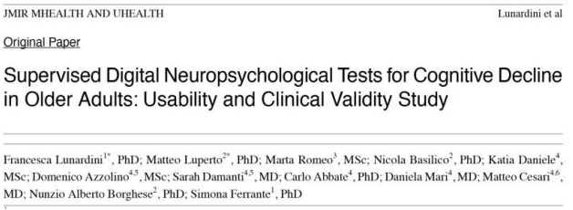

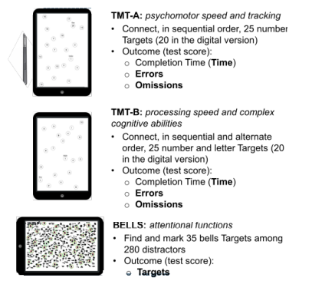It regards the development of a supervised digital neuropsychological test for cognitive decline in older adults. There is the assessment of usability and clinical validity. It started from the rationale that computerized neuropsychological testing, to be performed in a home environment, can be helpful in anticipating the screening for cognitive decline, thus extending the duration of independent living. If we can provide an app, which is more or less a sort of serious game, and we ask seniors to use it, we collect the results and we can screen the cognitive decline of these people. We can have an indication of the situation that is degenerating at the point of need, so not only after that the situation is too serious or when it is too late. In a new world in which we are using a lot of technology, we can somehow anticipate the care. This study developed implied three neuropsychological tests that are normally used in clinics that are the TMT-A, TMT-B and the BELLS:

The TMT-A is used to assess psychomotor speed and tracking. The used is asked to use a pen and connect the points on the screen in the right order, so in sequential order (which are numbered), in the fastest way possible. Normally, the outcome in this test is a score which depends on the completion time, the errors, and the omissions. So, what is evaluated by neuropsychologists is the time the user takes to complete the test, the number of errors, and the number of omissions, so how many numbers the user skips completely. The TMT-B is exactly the same of TMT-A, but in this case, there are numbers alternated with letters, so 1, A, 2, B, and so on. So, the aim is to connect in sequential and alternate order numbers and letters and the outcome are the completion time, the errors, and the omissions. Instead, the BELLS test is completely different. It assess attentional functions. It asks subjects to find bells in a figure, where there are many other objects. So, the aim is to find and mark 35 bells among 280 distractors. the number of bells found in a maximum of 5 minutes is the result, so the outcome is the number of targets.

Regarding the design approach and the definition of requirements, meetings and focus groups with neuropsychologists, geriatricians and engineers were carried out and the following requirements were gathered:

* Test supervision should mimic the one offered by the neuropsychologist during the paper-based version of the test. Thus, events requiring supervision should be recognized to trigger the related intervention. Requirements are important because, to replicate the test, we should also replicate the same supervision that the doctor is doing during the test. For instance, if in the TMT there is an error, the doctor must always carry a similar procedure. We should somehow ask to the experts what is done and replicate it with more fidelity possible.
* Test raw data and indicators should be stored and accessible for evaluation by authorized experts. We would like also to store other data, not only the completion time and the number of errors. So, we can also measure other indicators that can be additional features that we can use in our digital tool.
* A replay functionality should be provided to allow clinicians to remotely inspect the test after its execution. When a doctor is asking the subject to do a test, he/she is assessing the result, but he/she is also observing how the test is done, during the test itself. This is something that may have an effect in the evaluation. This replay function allows us to do an evaluation of the test remotely. So, given that we have a replay, we can understand that we have a test that is digital and a replay version of the test that is assessed by supervisors, so the same test can be automatically assessed by the digital tool and by the supervisor. This is a good way to assess validity on absolute values.
* The digitized version of the test should be conveyed by standard consumer technology.
* The digitized version of the test should be intuitive and allow easy interactions with the user.

The system structure this study develop is represented in the following figure:

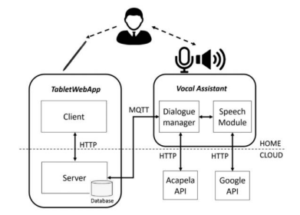

The digital test is based on a tablet and on a test to recognize speech interaction and they were using some UML workflow/activity diagrams in the requirement gathering, in order to understand all the steps.

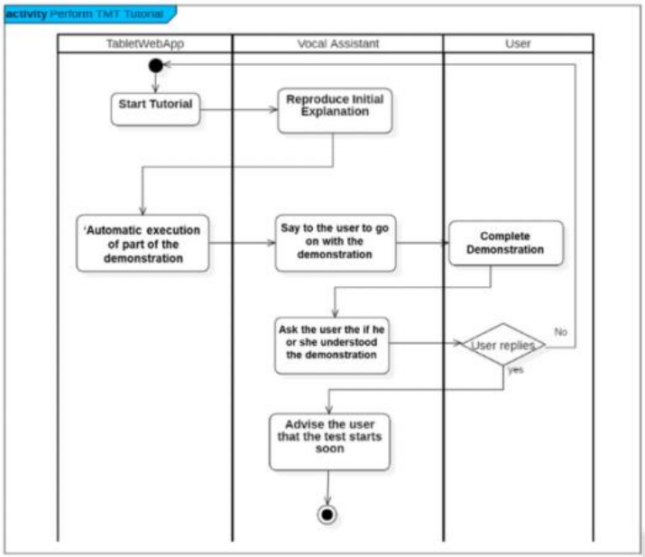

So, UML was used to define the final flow of the test with experts. For instance, when a subject is doing the TMT there is a tutorial, so it is not the test starting but there is a sheet with five points explaining how to perform the test. So, the tablet starts the tutorial and reproduce the initial explanation that the doctor does before the test. Then, there is an automatic execution of part of the demonstration, then the user is asked to go on with the demonstration and completes the demonstration. Then. The user is asked if he/she understood the demonstration and depending on his/her answer, he/she starts the test or refollow the demonstration. This is a prototype of the interaction that is normally done under the supervision of an expert. A prototype of the test activity is represented in the following figure:

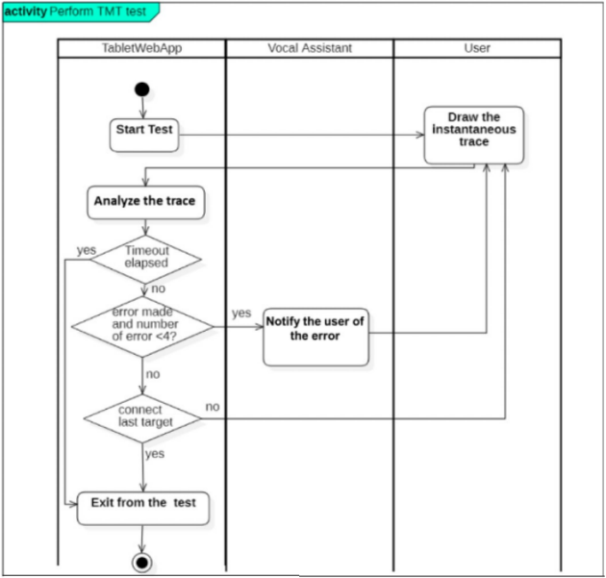

So, they were using these graphs in order to interact with the clinicians and understand if the workflow was coherent with expectations. Then, they also did early testing of the prototype on four elders in order to have additional feedbacks. The feedback was leveraged to improve the system and fine-tune the interface and the interfacing modalities:

* implementation of palm rejection (big issue)
* inclusion of additional written indications to facilitate test.
* comprehension and execution.
* implementation of specific software improvements to minimize errors in the automatic scoring.

Moreover, they did a functional evaluation to analyze if the workflow was respected:

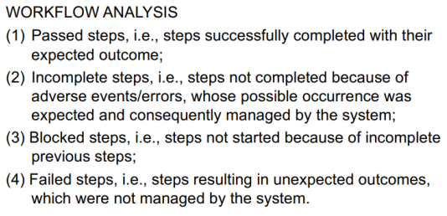

It is a sort of checklist to see if they succeed/failed in some steps of the workflow.

Speaking about the clinical validation (assess of the clinical validity), the protocol consisted in asking each subject to do:

* The paper-based tests during the neuropsychologist visit.
* The digital tests carried out 2 hours later (after the visit).
* Fill in questionnaires to evaluate usability acceptance and satisfaction.

Here there was a problem given by the context, because the test could be done only during a neuropsychological visit, so the doctor was administering the paper-based test during the visit, and then, after the visit, the digital test was carried out. This means that we are creating a bias, that could be a systematic error, but this was the only way. The digital test computes the scores automatically and allows the reply function to let the doctor compute the results afterwards.

Results that the test could provide:

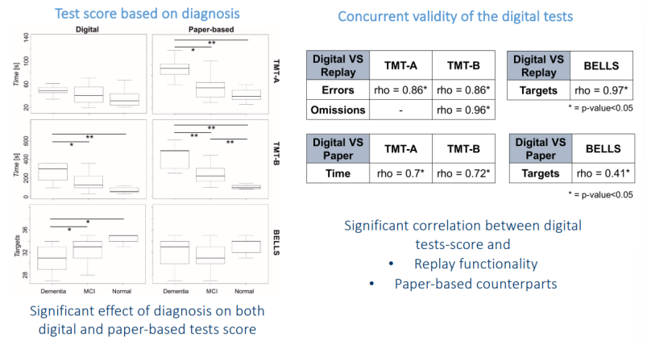

They compared, statistically speaking, the three groups performing the digital test or the paper-based test, in terms of the variables that are exactly the outcomes scores of the paper-tests, so the completion time, or the number of errors or omissions.

From the results, we see that both the paper-based and the digital-based test have the same trend in the three groups and in some cases, we also notice that a difference was more present in a digital version rather than the paper version. Moreover, they did the concurrent validity that could be done digital vs replay or digital vs paper.

This was just an example to let us understand that, given the context, we should understand how to assess clinical validity. This does not allow to assess reliability, because the subjects were visited once every six months and to organize a test asking them to come to the hospital every week was impossible. To also assess reliability, it should have been everything only remotely (no paper-based test).

Finally, the following table reports the results of the system acceptance:

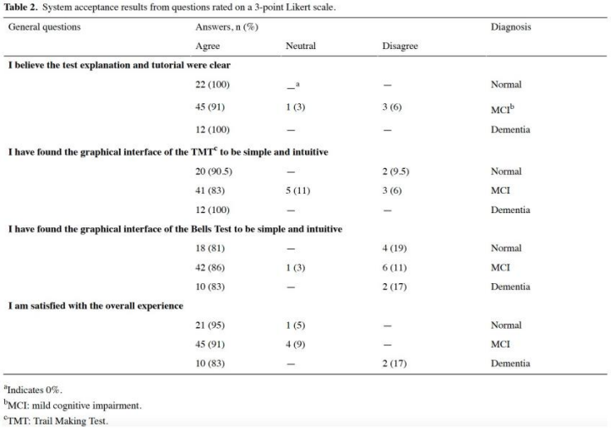

This was done with all the groups of participants, because it was interesting to see how usability was perceived differently by people that are cognitively different. Having a digital test means that we can validate clinically the gross results, so in this case the number of errors, the time, and the omissions, which is what the clinical scale does, but then we also have many more additional things that we can evaluate. In this case, for example, an additional indicator were the visuo-attentional strategies:

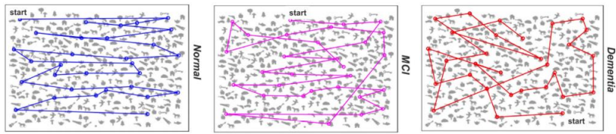

We may notice that a normal patient is screening the tablet from left to right to find in the minimum time the maximum number of bells. Instead, when the patient has dementia, it does it randomly, looking for things wherever. This is a visual attention strategy that gives important information ad can add meaning. For example, in the world of machine learning this type of information is important.

# Digital medicine for Ageing in place

Aging population will impact on public costs and place new demands on health system:

* 1.5 billion people over 65 by 2020.
* 46% of injury-related costs are due to people over 65.
* Need for proactive solution.

Own’s home is the elder’s preferred environment, but elders are admitted in nursing homes too early. The idea is to **change the model of care** offering **home-based solutions** tailored on each user. We would like solutions that makes elderly as independent as possible extending the time before admitting them to a nursing home.

Frailty, a clinically recognizable state of increased vulnerability, progresses slowly but constantly over time. Clinical monitoring occurs through sporadic geriatric visits that often happen too late. **Regular** **monitoring** of daily activities is needed to detect early signs of decline and allow prompt intervention. The process of degeneration has a preclinical period where symptomps are not visible, but the degeneration could be detectable. A prompt intervention would decrease costs and improve the outcome of the treatment.

WHO recommends 150minutes/week physical activity, mental activity, and participation in the community life. Digital medicine role is to provide adaptive stimulation of the elder through cognitive or physical activities to counteract decline.

The aims are:

* Assist the elder in an independent living at home.
* Maximize the elder’s motivation toward an active lifestyle.
* Detect early signs of decline to enable prompt interventions.

## Proposed solution

Continuos and transparent home-based monitoring of age-related decline from wearable devices to smart IoT objects of daily use. Obstructive monitoring is not well-accepted.

Following sections are the summary of a professor study.

## Smart internet of things objects

**Smart Ink Pen:** handwriting is a biomarker of fine manipulation and motor-cognitive skills. It’s transparently usable by the user. There are not other devices for the pen to be used. Just the pen.

**Smart Insoles:** alterations of gait in elderlies are important precursors of falls.

**Smart Ball:** decreased grip force is one of the first indicators of frailty. The first force lost is the grip force.

### Handwriting monitoring

Rationale: handwriting is an important and high-value task entailing a blend of cognitive, perceptual, and fine motor skills; its monitoring has been proved useful to assess age-related decline or neurological dysfunction.

The functional requirements are:

* Quantitative writing and tremor evaluation.
* Extracted features automatically uploaded to the cloud. There is no need, for example, to sync data with the smartphone.
* Ecologically valid. Monitoring the gesture exactly how it is. I’m not forcing the user to write specific sentences in a specific surface.
* Easy to use.

So, it is important to understand what elderlies usually write; shopping list, crosswords, etc…

**Technical requirements**:

* Tip pressure, 3D axis accelerations, and 3D gyroscopes.
* Must be evaluated based on the user, e.g., for elders’ pressure up to 4N while for children up to 8N.
* Do we want real-time transmission? If not, the pen must have a storage device for at least 10-15 minutes of usage.
* The weight can’t be excessive.
* Ergonomics, LED for battery discharge.

How can we **validate** the proposed solution?

* Validation of the functionalities: data storage is reliable? The size is enough? Calibration procedure? Is data transmission stable?
* Validation of the indicators: how to post-process the stored data?
* Elders’ acceptability.

**Planning of the validation tests:**

1. Verify the reliability/validity of the sensors:
   1. Validity of the force sensors.
   2. Validity of the inertial sensors.
2. Verify the reliability/validity of the indicators:
   1. Validity of the algorithms to segment the signals.
   2. Reliability of the indicators c) Evaluation of acceptability.

#### Validity of the force sensors

How much are we able to measure the true value?

**AIM**: validate the force exerted on the pen tip during handwrting.

**Methods**: compare the force measured by the pen to the force measured by an ad hoc sensor, gold-standard (load cell), in both static and dynamic (during handwriting) conditions.

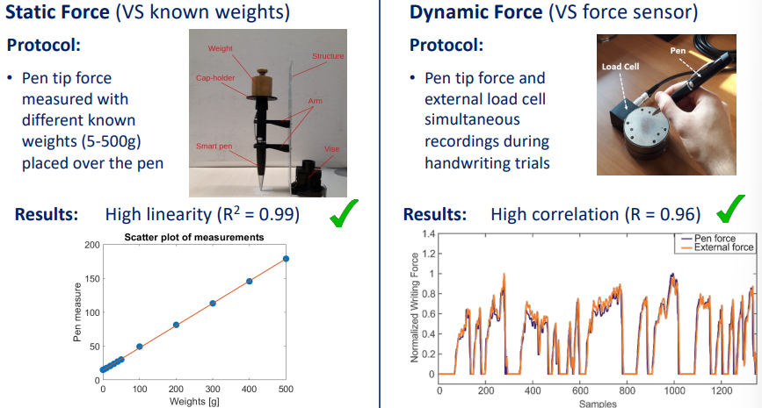

#### Validity of the inertial sensors

**AIM**: Validate the tilt angle of the pen measured by the inertial sensors.

**Methods**: comparison of the tilt angle obtained by the inertials sensors of the pen, and the same angle obtained using an optoelectronic system (external gold-standard) during handwriting trials.

Protocol: free handwriting trial (6 straight lines done at 2 different pen inclinations).

Data analysis: linear correlation between the angle computed from the pen inertial sensors and the one obtained by the optoelectronic system (gold-standard).

#### Validity of the algorithms to segment the signals

**Aim**: validate the algorithm developed to segment the signal in «on-air» (no force) and «on-sheet» (pen touching the sheet).

**Methods**: compare the segmentation obtained from the signal measured by the pen to the manual segmentation obtained from the external gold-standard sensor during handwriting.

Protocol: one subject was asked to do a free trial, writing with the pen on a paper placed over the external load cell. The trial was repeated with 10 different pens.

Data Analysis: data acquired by 3 pens were used to optimize the segmentation algorithm. The two segmentation algorithms were compared using a Bland Altman plot on the other 7 trials.

#### Reliability of the indicators

**Aim**: verify the reliability of the indicators estimated on the target population (healthy seniors) during free handwriting.

**Methods**: sample size calculation for reliability -> About 22 subjects were needed if we consider a statistical power of 80%, error type I 5%, ICC of 0,5 chosen according to previous literature.

Protocol: test re-test, a free handwriting trial repeated twice. 1 hour between the 2 trials.

Data analysis: compute the ICC on «In-air time», «On-sheet Time», «Writing Pressure».

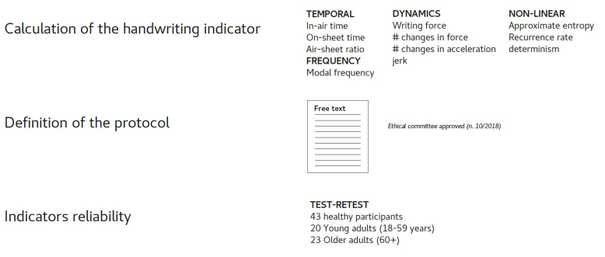

Investigating age-related differences in writing and tremor indicators. Protocol: 7-line free text writing (the first trial of the 2 carried out for the test retest). 43 subjects in 3 groups:

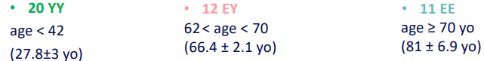

Results: In-air time and In-air/On-sheet ratio during handwriting increase with age. Tremor: more regular patterns emerge with age.

#### Evaluation of acceptability

**Aim**: To evaluate the usability of the long-term not supervisioned remote use of the pen on the target population (healthy seniors).

**Protocol**: pen used standalone at home by 24 seniors for 3 months. At the end of the period of testing the acceptability with an ad hoc questionnaire. 4 questions, in a 1 to 5 Likert scale, using 1 for “totally disagree” and 5 for “totally agree”. The median and interquartile scores obtained for each variable were:

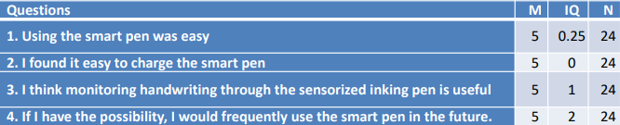

### Gait monitoring

Rationale: slow walking speed is a widely used criterion in geriatric assessment. Alterations of gait in elderlies are important precursors of falls.

**Functional requirement**: design an ecological solution that monitors daily life gait and is sensitive to subtle changes in gait pattern.

**Technical requirement**: use of sensorized insoles integrated in a mobile app.

How to maximise user’s acceptance?

* Adoption of smart insoles easy to be charged and used. Magnetic charge: the user doesn’t want to remove the insoles to charge them.
* Design a mobile app completely transparent to the user (no interaction required).

How to be sensitive to little changes in gait pattern?

* Integration of dual-task paradigm.

**Proposed solution:** mobile app for ecological outdoor gait monitoring through instrumented insole:

* FeetMe® Insoles sensorized with pressure sensors and 3D accelerometer. BLE communication with Android smartphone.
* Phone registry monitoring to discriminate single and dual task gait.

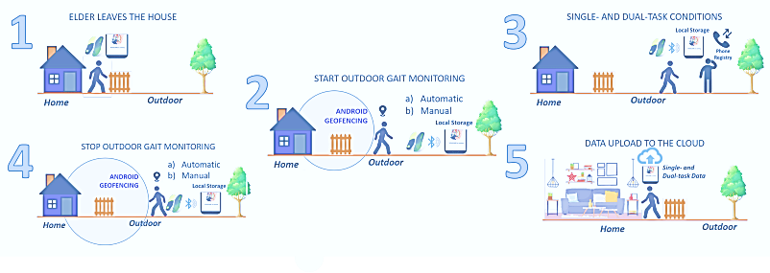

**Testing activity**: Investigating differences between single- and dual-task conditions during outdoor gait in seniors.

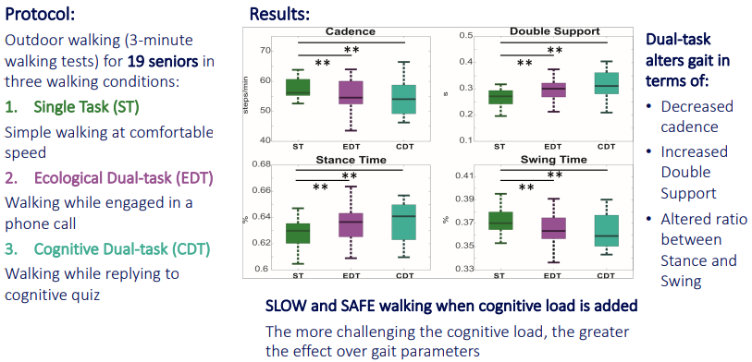

### Grip force monitoring

Rationale: muscle weakness is estimated from the hand’s maximal grip strength. Strong relationship between lower grip strength and age-related decline.

**Functional requirement**: design a solution to offer a telemonitoring of grip strength.

**Technical requirement**: range of measurement (0-60N).

**Challenge**: one of the key obstacles for the uptake of telemonitoring is user’s acceptance.

It is important to be sure that when used, the user should apply maximum grip.

**Proposed solution**: serious game to transparently measure hand grip strength and endurance.

* Controlled by the smart anti-stress ball.
* Implements the American Society of Hand Therapist (ASHT) protocol to guarantee adherence to the clinical procedure.

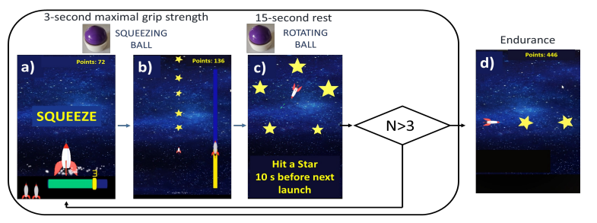

#### Evaluation

1. Pressure validation against an external force actuator
   1. To choose of the inflated pressure to be used.
2. Clinical validation against a gold standard – Jamar (Test on subjects)
   1. Concurrent Validity.
   2. Reliability.
   3. Usability.

**Pressure validation**

Reliability (VS force actuator).

Protocol:

* Linear actuator exerts forces from 10-200 N (Δ: 10 N) on the ball.
* 4 initial pressures (P0): 1.0, 1.1, 1.2, 1.4 bar.
* 2 repetitions for each session.

Both validation and reliability (repeated test). This was done to choose the best inflation to the ball.

**Testing activity**: Clinical validation with Jamar and testing on seniors

Testing on 26 older adults (73.96 ± 6.52 years)

1. System Validity: strong, significant correlation between the maximal handgrip strength acquired with the two devices (smart ball and Jamar dynamometer).
2. System Reliability: excellent repeatability of the 3 maximal handgrip strength trials recorded with the smart ball during game play.
3. System Usability: strongly positive system usability (positive SUS score ≥ 68).

## The new frontier

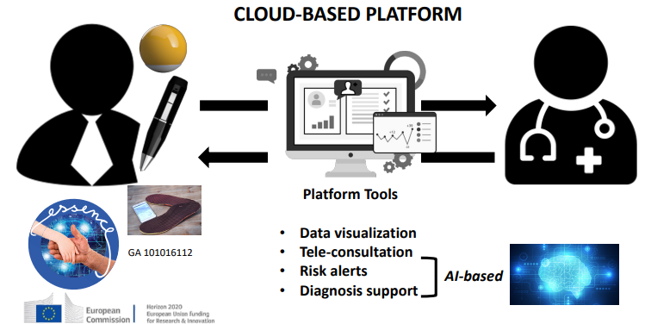

## Use of the object

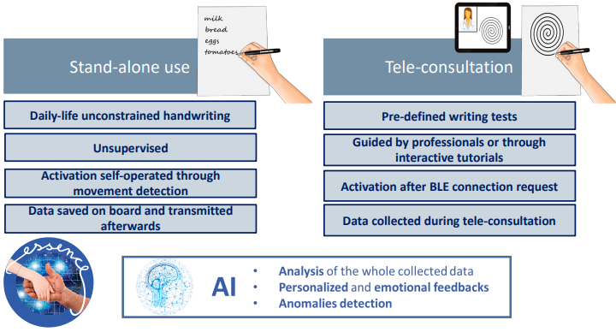

# Serious games to characterize the graphic gesture in pre-school age

Dysgraphic people have writing skills below the expectancies, given the age, intelligence, and education. This leads to decreased self-esteem and behavioral problems with early school abandon.

## Diagnostic process

Dysgraphic children are the 5% of the population but there is a 22% of people that have an uncertain diagnosis.

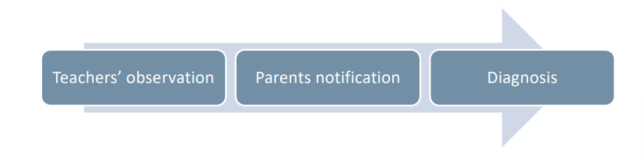

Teachers are the first screener for dysgraphia detection and parents are active actors in this scenario.

Limitations of the current diagnosis process:

* Diagnosis comes late: in the third class of the primary school.
* It is based on the observation of the result of handwriting and on the execution speed. No other features are observed which can be useful to detect the pathology.
* Long waiting list.

## Stakeholders

The main stakeholders are children, parent and families, teachers and schools, and child neuropsychiatry unit.

## The IndiPote(dn)S project

From literature: “the developmental origins of the health and disease hypothesis proposes that the physiological processes of developmental plasticity operate in early childhood but have the potential for adverse consequences in later life”. It is important to NOT wait till the third grade.

IndiPote: focused on identification and empowerment of children with lackness in learning domain.

Target: last year of kindergarten, 1st and 2nd grade of primary school. 120 schools and 14613 children. It is a longitudinal study.

### Phases

* **The analytic observation:** 95 questions assessed by trained teacher. Supported by web-app and database.
* **Prompt detection.**
* **Empowerment**: they also provided each class a **vademecum**. It provides teachers with operational ideas to empower basic skills necessary for learning in the different domains.
* **Longitudinal monitoring.**

### The needs:

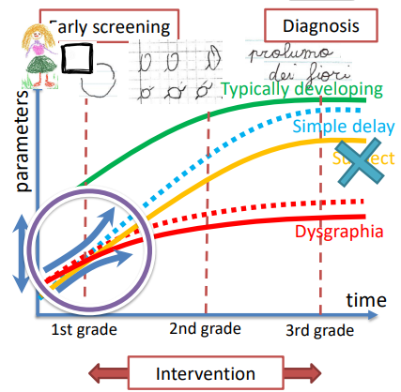

Subjects with tipycal development reach the plateau in third grade.

A detected difference at the beginning could be both a FP and not. But with empowerment the TP could be led to the typical plateau at most with a delay. So, it is important to predict the risk level at an early stage:

* Identify quantitative alteration.
* Empower lacking abilities.
* Assess interventions effectiveness.
* Pre-clinical screening:
  + School-level screening.

The technology should be able to disclose subtle changes and enable continuous monitoring.

### Needs to requirements

Need: early detect weaknesses potentially correlated to dysgraphia.

Requirements:

* Quantitatively reveal alterations in writing production.
* Detect potential weaknesses before handwriting is mastered.
* Be easily accessible.

### Technology

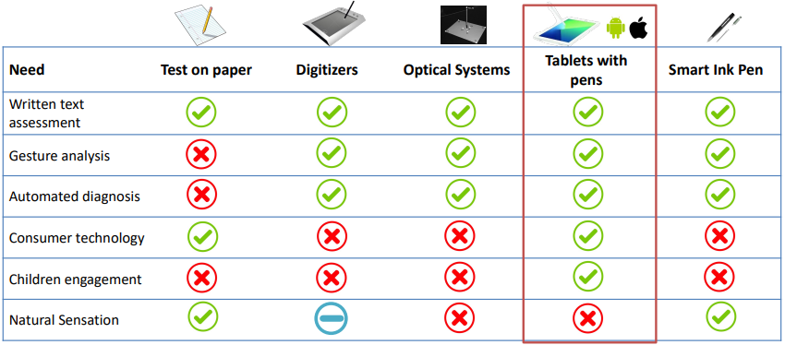

### Serious game

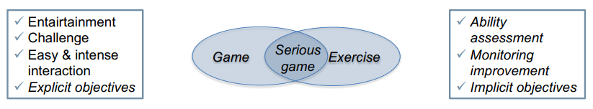

Design a serious game aimed at **early** **identifying** quantitative alterations in handwriting analysing drawing activities.

### Implicit and explicit objectives

Explicit: «Go through the tunnel as fast as you can, without leaving the edges»

Implicit: signal to noise velocity peaks difference, pen stops, pen tilt, speed, pressure, …

### Alterations in dysgraphic writing

Isocrony (the bigger the letters the fast I write) and rhythm reproduction.

* Isocrony is completely inexistent in dysgraphic children.
* They also have problems in reproducing a rhythm, for example of a song.

Are these rules true also at preliteracy level? We can ask for shape instead of letters since they do not know how to write.

Speed-accuracy trade off (SAT): the faster you write the more inaccurate you are. In dysgraphic this law is not “well respected”.

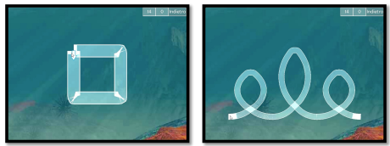

At preliteracy level we can ask to trace simple shapes. Are dysgraphic people respecting the law (that can also be translated in “the more difficult the task the more time I need to complete it”).

It is really important to provide tutorials and trials before the measurement: for example, in the second image they could not follow the loop track, and this could lead to biases and wrong results.

### Value proposition

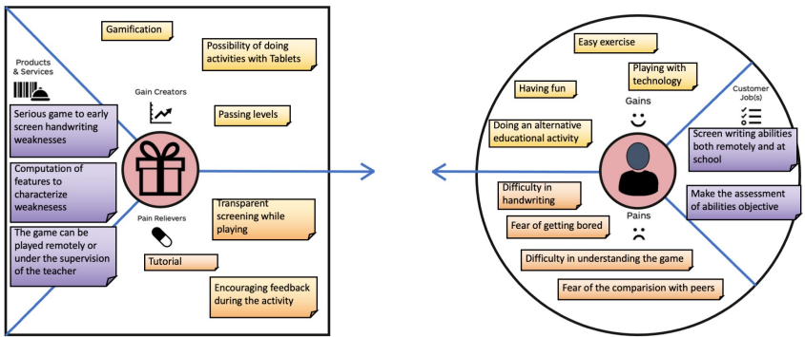

### Evaluate the developed technology?

Is the serious game efficient in measuring isocrony and in assessing rhythm? Pilot testing also with little population:

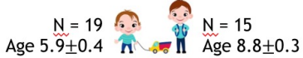Kindergarten vs third/fourth grade where handwriting has been mastered.

Is the serious game efficient in predicting the risk of dysgraphia? Is the serious game appreciated by target users?

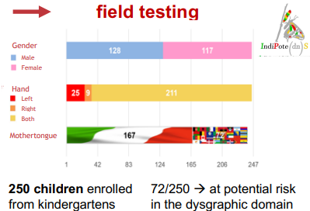

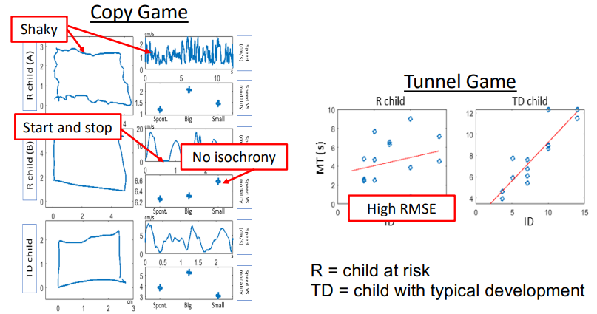

The square was good but there is no isochrony. This is a clear example that only the final view is misleading. R child (B) would be considered completely not at risk from the square picture if data on execution behaviour was not availablev .

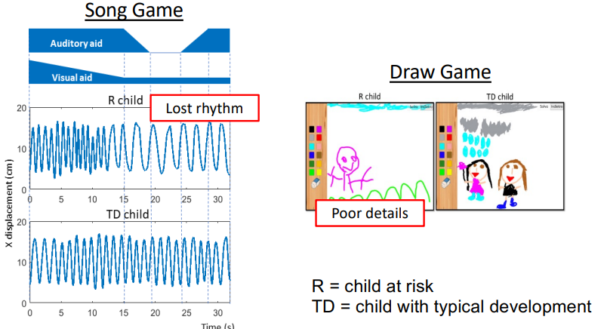

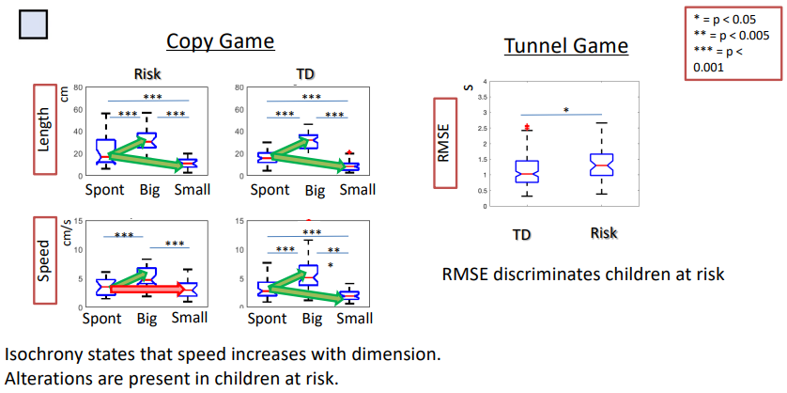

Alterations in isochrony are **statistically** present in children at risk.

### Longitudinal study and collected data

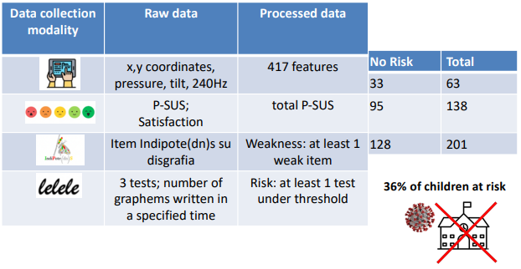

36% at risk: is it because of covid? Speed of learning decreased because of it.

Since there are enough data, we can both perform statistical detection or take advantage of machine learning algorithms:

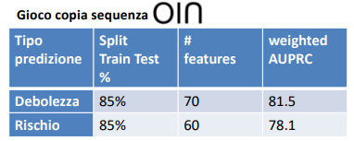

### Usability: Pictorial System Usability Scale

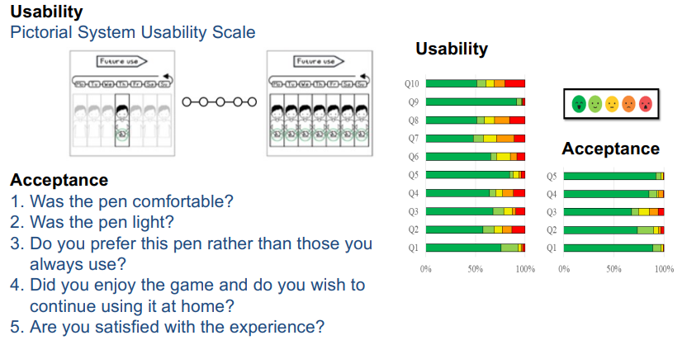

## Serious games for empowerment

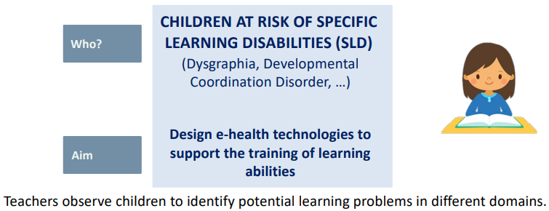

The focus group is made of 6 primary school teachers, 9 children from 1st, 2nd grade, 9 parents and 7 clinicians.

First Phase: description of the overall project with the support of a ppt presentation. The aim is to collect feedback.

Second Phase: description of the tools through videoclip to collect more detailed feedbacks.

### Strategies to maximize engagement

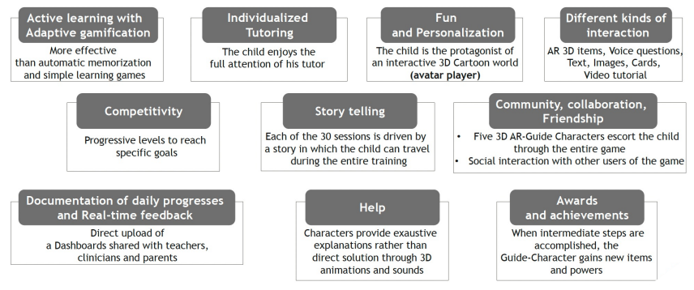

### Iterative development and testing process

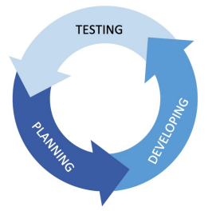Database of words, sentences, and images categorized in various levels of difficulty by clynical experts. This database cannot be constructed by the developer.

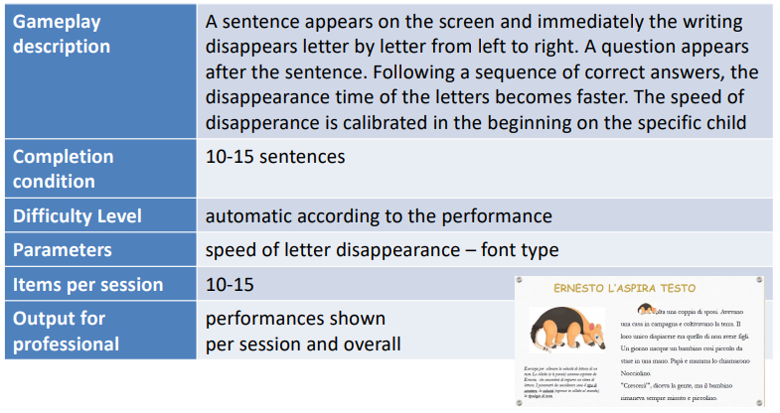

Speed of disapperance and test difficulty changed based on previous score of the subject. Text and time assessed by the clynical experts.

Interactions with children is important to improve the game: for example, better graphic, changing the position of the commands, …

#### The Island of Mini Games

Narrative framework to boost engagement. Each learning domain has a guide character and a different environment in the Island of Mini Games. Bianchetto the avatar needs to collect points to defeat the enemies (Inks).

## Towards a new school model

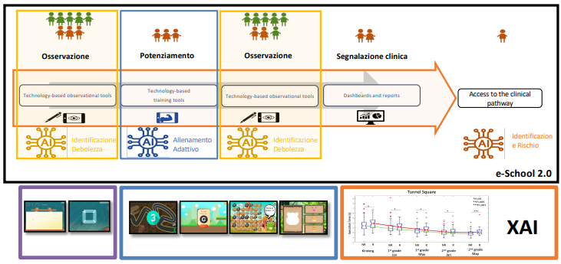

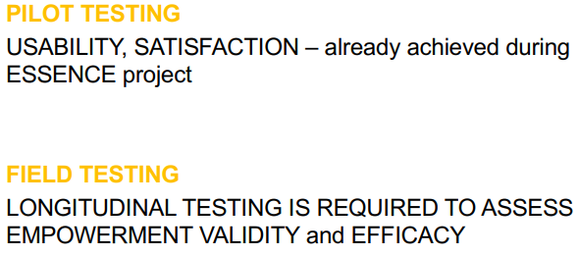



Field testing should **always** have a control group! Are they improving because of the serious game or not? We need to consider that, in particular at the beginning of primary school, children are learning to write as the standard progress of primary school teaching.

# E-Health for Clinical Research Informatics

“Evidence based medicine is the conscientious, explicit, and judicious use of current best evidence in making decisions about the care of individual patients.”

EBM integrates the 3 components in the decision-making process: clinical expertise, patient preference, and best evidence from systematic research. E.g., the clinician should follow guidelines but also personalize them for the specific patient.

Steps of evidence-based medicine:

1. Acknowledge uncertainty.
2. Ask a question.
3. Acquire evidence.
4. Appraise found evidence (search in literature and assess clinical research studies on humans).
5. Apply to patient.
6. Assess practice.

Evidence requires systematic observation:

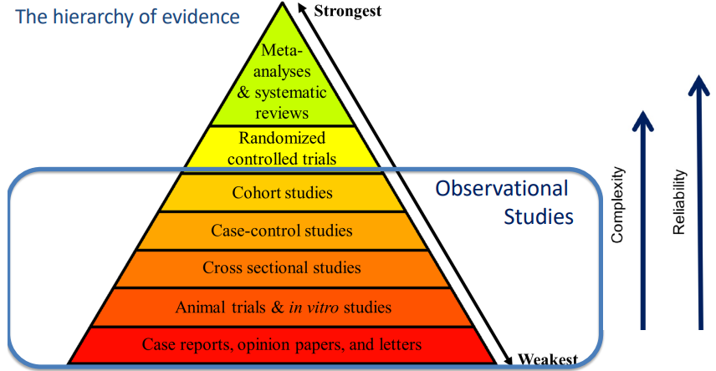

### Case series and case reports

Case series: Reports on a series of patients with a pre-identified problem.

Case reports: They involve a report on the intervention and outcome for a single patient.

### Case Control Studies

This design involves choosing 2 patients or 2 groups of patients who were exposed to 2 different interventions. The investigator retrospectively looks back to which group, or patient, achieved a better outcome.

### Cohort Studies

This design is also calles a prospective study, or a longitudinal study. It involves the selection of a large population of people who have the same condition and/or receive a specific intervention. They are followed over time and compared to a group not affected by the condition.

## Randomized Controlled Trials (RCTs)

The difference of RTC with cohort studies is that in RTC the patients are divided in the control group or not in a random way. **The doctor does not choose who goes in which group**.

A randomized controlled trial (RCT) is a type of scientific experiment used to test the efficacy and efficiency of a service in healthcare, such as a new technology, methodology, treatment, or drug therapy. RCTs are condisdered the «Gold Standard» for establishing the effect of a treatment.

* Study involves the randomization procedure.
* Subjects in the study are randomly allocated to a study group and a control group.
* Each subject has an equal chance of being assigned into one of the groups under investigation.
* The control group receives the best treatment currently available or a sham treatment (placebo).

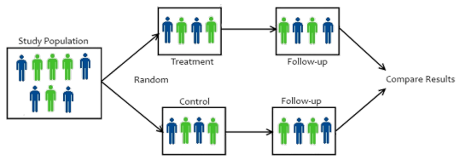

The specialist in charge of dividing patients must not be aware of “what comes next”, i.e., who will be the next person to be assigned to a group.

### Blindness

Assuring a complete blindness of a RCT means that participants, those administering the interventions, and those assessing the outcomes must be completely unaware to group assignment.

* Double blind = neither the patient nor the assessor knows the patient’s group allocation.
* Single blind = only the patient or only the assessor do not know the patient’s group allocation.

The assessor, if he is blind, assess the condition of a patient without knowing his group.

Some studies cannot be blind, such as surgical interventions.

## Systemati reviews

A review of a clearly formulated question that uses systematic and explicit methods to:

1. Identify, select, and critically appraise relevant research.
2. Collect and analyze data from the studies that are included in the review.

Why do we need it?

* + Too many trials.
  + Not all studies are equally well-designed or interpreted.
  + To summarize evidence from studies addressing the same specific question.
  + To limit bias.

Systematic review is usually restricted to RCTs. A group of reviewers search the available literature via bibliographic databases and retrieve all articles on a specific topic. Critical evaluation of methodologies and content. The final product is a synthesis of the properly completed and meaningful research into information that is relevant to medical practicioners/clinicians, for example **creation** of **guidelines**.

### Meta Analysis

A subset of systematic reviews that use statistical methods to combine and analyze multiple studies.

Conclusions produced by meta-analysis are statistically stronger than the analysis of any single study (increased number of subjects, greater diversity among subjects, or accumulated effects and results).

## Cochrane Library

The Cochrane Database of Systematic Reviews is the leading resource for systematic reviews in health care.

## Transfering evidence into practice

A drawback is that transfering evidence into practice is very slow. We are talking about years.

## International clinical guidelines and clinical pathways

The INTERNATIONAL CLINICAL GUIDELINES (ICG) are “systematically developed recommendations, grounded on the current scientific knowledge (and timely updated), to assist practitioner and doctors in the choice of the appropriate care for specific clinical circumstances”. This are general reccomandations (e.g., use this or this and not that for this scenario).

CLINICAL PATHWAYS, or Care Pathways, are grounded on ICG and scientific evidence, and define the multidisciplinary activities for a specific patient group. CP are the local practises used by the staff involved in the process at the local domain.

## RCTs design

* PARALLEL DESIGN: each group undergoes only a treatment and groups undergo treatments in parallel.
* CROSS OVER DESIGN: each participant undergoes all the intervantions one after the other. The order of the interventions is randomized. This design is appropriate only for chronic patients.
* FACTORIAL DESIGN: two or more treatments are evaluated not only by themselves but also in combination with the others. no treatment vs treatment A vs treatment B vs treatment A + B.
* CLUSTER TRIALS pre-defined homogeneous clusters of individuals (e.g., clinic 1 and clinic 2) are randomly allocated to different study arms (i.e., intervention or control group).

### Bias in RCTs

BIAS = systematic error that may induce misleading conclusions about the efficacy of one treatment over others.

* **Selection** **bias** can arise if the PI chooses which patients to enrol according to his experience and capacity to predict the outcome -> enrolment should be done according only to inclusion/exclusion criteria, and it should preceed randomization and allocation.
* **Allocation** **bias** can arise when the PI can predict the allocation of the next enrolled patient -> allocation concealment to protect the randomization process.
* **Assessment** **bias** can arise when the assessor is aware about group allocation of the patient, he/she is evaluating -> assessor blindness.
* **Stopping** **bias** can arise when the PI stops recruitment when results are good -> sample size should be computed a priori.
* **Publication** **bias** can arise because papers reporting positive findings are often considered more likely to be published than papers that do not show any statistically significant difference.

### Clinical research process

RCTs should be adequately designed and transparently reported to allow critical appraisal of the validity and applicability of their results.

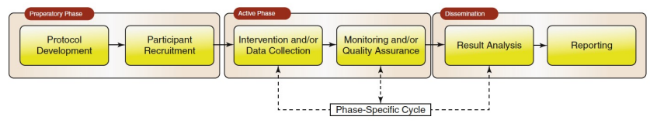

Actors involved in the clinical research process:

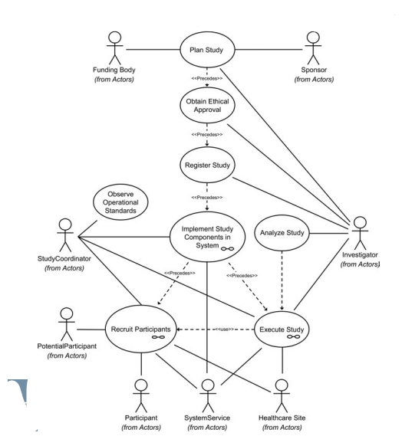

#### Preparatory phase

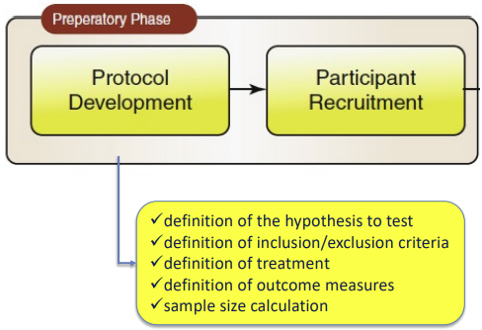

Sample size must be fixed a priori:

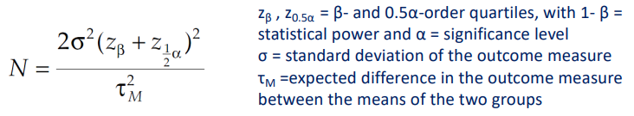

Thus:

* The more the outcome is noisy (high σ) the more N is high to demonstrate efficacy.
* The more the τM is low the more N is high to demonstrate efficacy.
* If we expect a high (low) difference between the two groups, a low (high) sample size is necessary to demonstrate the superiority of one of the groups with respect to the other.

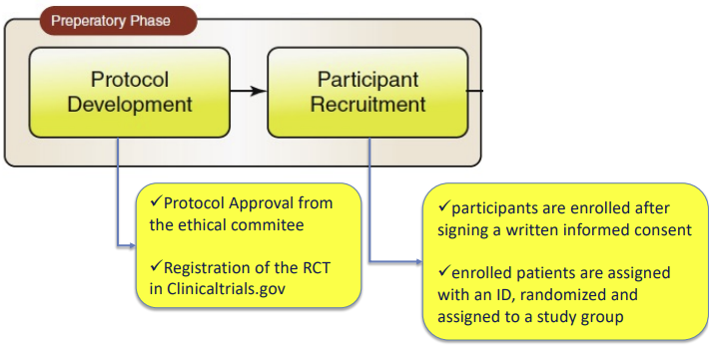

Then we must submit and receive the approval by the ethical committee. Participants sign a written informed consent (which is also approved by the ethical committee).

#### Active phase

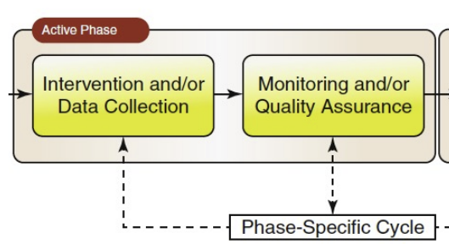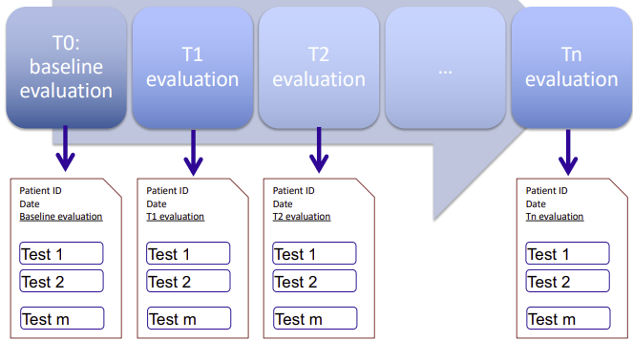

Data collected multiple times.

#### Dissemination phase

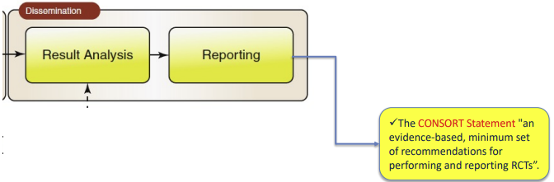

### RCT process outputs

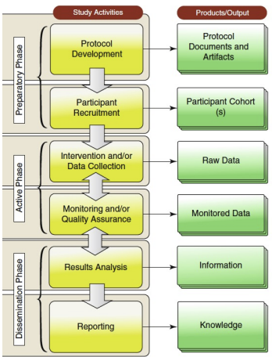

## Tools for clinical research informatics

**Definition: “**Clinical Research Informatics (CRI) is the the sub-domain of biomedical informatics concerned with the development, evaluation and application of informatics theory, methods and systems to improve design and conduct of clinical research and to disseminate the knowledge gained.”

### Overview of the tools

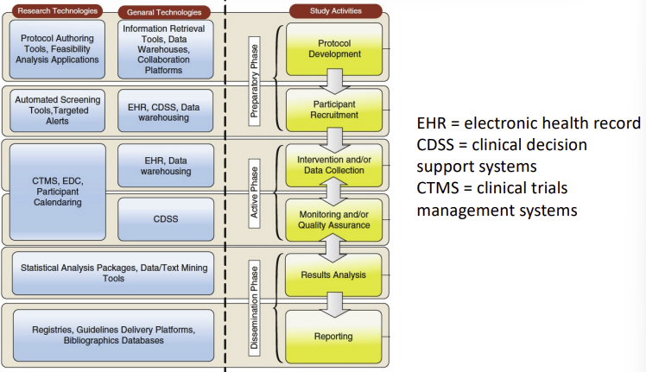

### Clinical Trial Management Systems (CTMS)

CTMS should include some of the following functional components:

* Protocol Management: enables the submission, version control and dissemination of the protocol and associated metadata.
* Participant screening and registration: allows to assess patients eligibility, register the enrollement saving the requested data at baseline for each participant (including the consent).
* Participant calendaring: allows the instantiation of the protocol schema (alerts for recruitment, assessments…).
* Electronic Data Capture (EDC): allows the use of electronic case report forms to collect the assessment data.
* Monitoring tool: implements logical rules to check or enforce data completion and assure data quality.
* Query and reporting tools: summarize and report collected data and export them for statistics.
* Securing and auditing: differentiated access according to roles.

Patient recruitment is the main cause of study delays. CMTS should facilitate patient identification from EHR and patient recruitment.

### Electronic data capture systems

A computerized system used in research trials and designed to collect clinical data in electronic form Minimum functions required:

* a graphical user interface.
* a structured database to collect all clinical data.
* a validation component for data collection.
* filtered data acces.

Electronic data capture systems allow to switch from case report form to electronic case report forms. Electronic forms have high data security, a flexible database structure, easier navigation and retrieval, simple data verification and a comprehensive report system.

### Examples of clinical oucome assessment

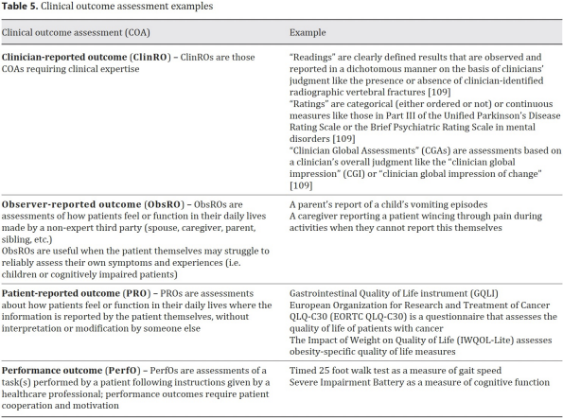

### Electronic Patient-Reported Outcome Measure (ePROM)

The ePROM is a data collection, reported directly by the patient and acquired by electronic methods, used in the implementation of clinical trials or elsewhere in health care.

Data collection technologies:

* Interactive voice response systems.
* Handheld devices.
* Tablet computers.
* Desktop or laptop computers.
* Digital pen.

### Which m-health applications can be integrated in RCT?

* Interventions delivered through mobile devices (e.g., behavior change interventions that help people quit smoking or lose weight, or mental health applications to address depression, anxieties, …).
* Diaries or applications to monitor therapy adherence.
* m-health to improve healthcare processes (e.g., vaccines reminders, visit reminders, results notifications, rules for diagnostics…).

### E-Health CONSORT statement

To allow reproducibility and comparability of the m-health tool a very detailed description of the tool is required:

* declare developers’ owners and sponsors.
* describe the history/development process and updates.
* describe the mode of delivery and the components.
* clarify instructions and settings.
* describe reminders and notifications used.
* describe any needed training.
* Report issues of attrition and use (adherence).

## Decentralized RCTs

RCT is no more in a single clinic but everywhere. RCT can be inefficient, and results can lack of generalization (external validity). Indeed, they have yoo strict protocols (far away from normal routine), eligibility criteria are too narrow, and people away from clinics cannot participate (rural areas).

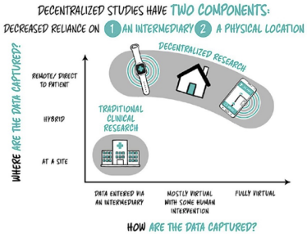In RCT data are collected by means of intermediaries (trained people).

In DCT data can be collected in different ways:

- Passively virtual (without intermediary).

- Actively virtual (the recruited person is doing something to allow data collection, e.g., electronic diary, e-PROM, …).

### Challenges for decentralize control trials

* Remote management of technology
  + Troubleshooting
  + Batteries
  + Internet connectivity
* Drugs management (not anymore centralized to few centers)
  + Decentralized drug shipping
  + Management of drugs (doses maintainance...)
  + More complex to maintain the integrity of the trial
* Wearable devices are still in early phases of development, they require clinical validation
* Cybersecurity

The best solution is an hybrid approach: **partially decentralized trials.**

### Recommendetions for DCT

**Selection of the best mobile technology to use:**

Mobile technology selection should be driven by:

1. Technical performance specifications and functional characteristics needed to measure the outcome of interest
2. Study needs (i.e., constraints and nuances of the central scientific question)
3. Needs and preferences of study participants.

Note that mobile technologies for data capture in clinical trials do not typically need to be approved or cleared as a medical device. The appropriateness of the selected mobile technology should be justified through verification and validation processes (validation against gold standards).

It is recommended to conduct feasibility studies before full implementation in large studies. Feasibility studies may help address unanticipated potential mobile technology issues.

**Data collection, analysis, and interpretation**

* Collect the minimum data set necessary to address the study endpoints.
* Collect appropriate metadata to provide sufficient contextual information to understand the outcome data captured
* Identify acceptable ranges and mitigate variability in endpoint values collected via mobile technologies
* Minimizing missing data

**Data management**

* Ensure the authenticity, integrity, and confidentiality of data over its entire lifecycle.
* Optimize data accessibility while preventing data access from unauthorized users (authentication of users and privacy notice for vendors of technology).
* Transparency of data process (informed consent)

# Biomedical Decision Making: probabilistic clinical reasoning

The question on which these two lectures are based on is “How the clinical decision supporting systems are working?”. We will take into account the diagnostic process and the expected value decision making.

## Diagnostic process

How to decide about a diagnosis?

**Diagnostic process phases:**

1. Make an initial judgment about whether a patient is likely to have a disease -> A priori hypothesis
2. Gather more information to reduce the uncertainty -> Diagnostic test execution
3. Update the initial probability estimate -> A posteriori hypothesis

Example: An elder is 70 years old and feels fatigue while walking, so in this case for example the probability of having an heart attack is 0.5, now he does an ECG during an exercise, depending on the outcome of this test the probability can move nearer to 1 or decrease and reach lower values.

### Methods to assess pretest probability

Uncertainty can be expressed through probability.

Probability (p) expresses a clinician’s opinion about the likelihood of an event as a number between 0 and 1.

* **Prior** **probability** = prevalence of an event in a specific population
* **Conditional** **probability** = the probability that event A will occur given that event B is known to occur p[A|B]: **Posterior** **probability**

While if two events are independent p[A|B] = p[A]

#### How to estimate pre-test probability?

* **Subjective** **estimate**
  + cognitive heuristics: a mental process that the clinician carries out the reply to this question: “What was the frequency of disease in similar patients whom I have seen?”. This can be the case of a very poor country in which data on populations are not available.
* **Objective** **estimate**
  + prevalence: the frequency of an event in a population; It is normally available in literature clinical prediction rules: they define how clinicians can use combinations of clinical findings to estimate probability. It is a set of clinical findings and corresponding diagnostic weights developed from systematic study of patients who have a particular diagnostic problem

### Classification of diagnostic test results

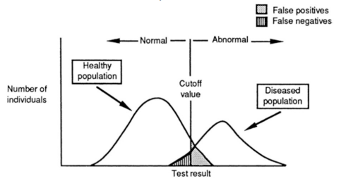

The choice of the cutoff value is very important. Healthy and diseased people distribution will always be overlapping. It is important to choose if we rather have more false positives or more false negatives.

We can measure test performaces using recall (sensitivity, or TPR), specificity (TNR), FNR, and FPR.

#### Choice of the cutoff value

The cutoff choice affects sensitivity and specificity.

* If the disease is serious and lifesaving therapy is available, minimize FN.
* If the disease is not serious and the therapy is dangerous, minimize FP.

#### Receiver operating characteristics curves (ROC)

The best way to characterize a test is by the range of values of sensitivity and specificity. Any given point along an ROC curve for a test corresponds to the test sensitivity and specificity for a given threshold of “abnormality” (Cut-off).

The cutoff choice should consider also cost, risk, discomfort, and delay of the test.

### Bias in measurement of test characteristics

Test characteristics are normally computed on a subset of study population. If the selected study population differs from the clinically relevant population in terms of average level of health and disease prevalence the computed characteristics are biased.

* **SPECTRUM** **BIAS** = it happens when study population include only very sick patients and healthy subjects (low FN à underestimation of FNR and overestimation of TPR = 1 - FNR)
* **TEST REFERRAL BIAS** = it happens when only the resulted positive cases undergo the gold standard (low TN and FN à overestimation of TPR, underestimation of TNR)
* **TEST INTERPRETATION BIAS** = it happens when the knowledge of the gold standard results affects the interpretation of the test results (TN and TP are overestimated)

If present, meta–analysis on diagnostic tests should be used to choose the best one according to the evidence-based medicine

## Post-test Probability

The third step is to make a “a posteriori hypothesis”.

Bayes theorem allows us to compute the probability that the disease is present, given that the test result is known.

We can also use the Odds-Ratio form of Bayes’s theorem:

$$\text{post-test odds}=\text{pre-test odds}×\frac{TPR}{FPR}$$

$$p=\frac{\text{post-test odds}}{1+\text{post-test odds}}$$

Another approach is the positive and negative predicted value computation (PV). It is less used because it is lesse generalizable. It is an alternative approach to estimate of the probability of disease in a person who has a positive or negative test.

Bayes’ theorem is the preferred method in the calculation of the post-test probability. Indeed, it computes the post-test probability of a disease for any prior probability. Instead, the PV computes the post-test probability constraint to a prevalence that is identical to that in the 2×2 contingency table from which the PV was calculated. PV suffers of generalizability.

Test specificity (TNR) affects primarily the interpretation of a positive test. Thus, if you are trying to rule in a diagnosis, you should choose a test with high specificity or a high LR+ (likelihood ratio). Test sensitivity (TPR) affects primarily the interpretation of a negative test. Thus, if you are trying to exclude a disease, choose a test with a high sensitivity or a high LR−.

### Common problems with probabilistic reasoning

If you decide to do 2 ore more tests you have to be sure that they’re independent one to the other, because otherwise you’ll obtain a wrong probability.

Common problems:

1. inaccurate estimation of pre-test probability
2. faulty application of test-performance measures
3. violation of the assumptions of conditional independence between 2 different tests applied one after the other
4. mutual exclusivity of diseases

## Expected-value decision making

How is it possible to choose between different alternatives given that each of them is uncertain? How is it possible to compare uncertain alternatives? How can a clinician determine which course of action has the greatest chance of success?

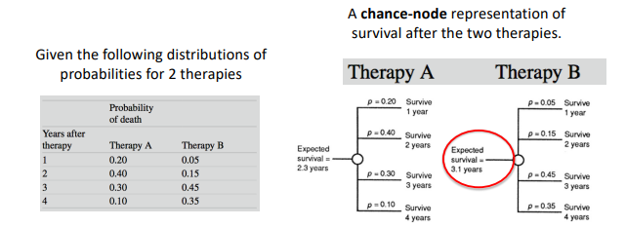

The probabilities times the corresponding years of survival are summed to obtain the total expected value (utility) in this case the expected survival; The expected value is a measure of the outcome that can derive from a therapy.

### Decision analysis

1. Create a decision tree: this step is the most difficult, because it requires formulating the decision problem, assigning probabilities, and measuring outcomes.
2. Calculate the expected value of each decision alternative.
3. Choose the decision alternative with the highest expected value.
4. Use sensitivity analysis to test the conclusions of the analysis.

#### Creation of a Decision Tree

Design the tree:

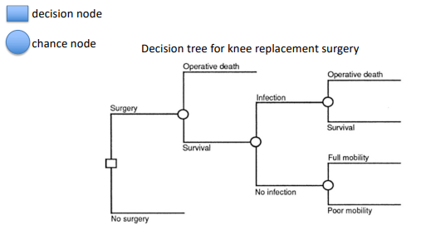

Assign probabilities to each branch and associate it to the outcome

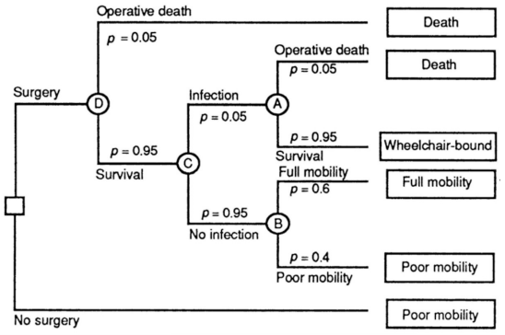

#### 2. Computation of utility values

For example, we can compute the QALY (quality adjusted life year). Outcome can be assessed in terms of length of life and quality of life.

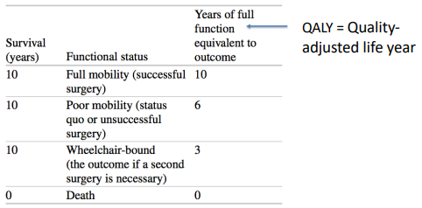

Complete the decision tree:

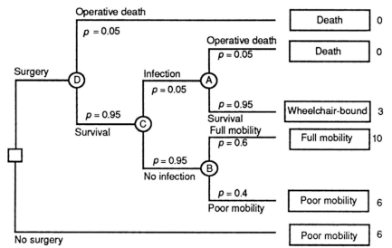

#### 3. Compute the expected values at each node

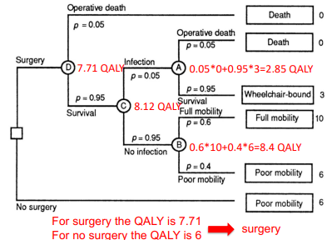

#### 4. Probabilistic Sensitivity Analysis

How does choice change when varying utilities and probabilities in a reasonable range?

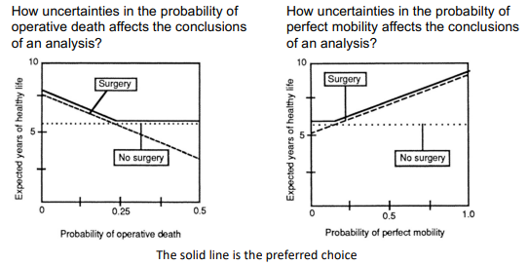

Dashed line: surgery. Dotted line: no surgery.

In the first plot, if the probability of operative death is less than 0.25, it is better to choose surgery, otherwise no surgery. In the second, if the probability of perfect mobility is less than 0.2 it is better to do no surgery.

How it works:

1. The analyst specifies a probability distribution for each parameter
2. The software chooses a value for each parameter randomly from the parameter’s probability distribution.
3. The software calculates the outcomes for each alternative.
4. For each evaluation of the model, the software will determine which alternative is preferred. The process is usually repeated 1,000–10,000 times.

At the end, the analyst can determine the proportion of times an alternative is preferred, accounting for all uncertainty in model parameters simultaneously.

The sensitivity analysis is the best method for evaluating uncertainty; indeed, it allows to examine any variable to see whether its value is critical to the final recommended decision.

## Other modelling approaches

* Influence diagrams are an alternative rapresentation for decision problems
* Belief networks are diagrams that have only chance nodes (no decision nodes). They are used to perform probabilistic inference.
* Markov models
* Dynamic transmission models
* Discrete events simulation models

## The role of probability and decision analysis in medicine

It is applied to the many decisions that must be based on imperfect data, and they will have outcome that cannot be known with certainty at the time the decision is made. Sensitivity analysis is very useful to understand whether uncertainty on specific variable should concern or not Decision making is also applied in the control of costs and in the development of guidelines Computers tools can help in the process of decision making --> clinical decision support systems (CDSS).

The decision is always taken by the doctor, this is just a way to support his decision.

# Clinical Decision Support Systems

Clinical decision support (CDS) provides clinicians, staff, patients or other individuals with knowledge and person-specific information, intelligently filtered or presented at appropriate times, to enhance health and health care.

CDS systems (CDSS) encompasses a variety of tools to enhance decision-making in the clinical workflow. These tools include:

* computerized alerts and reminders to care providers and patients;
* clinical guidelines;
* condition-specific order sets;
* focused patient data reports and summaries;
* documentation templates;
* diagnostic support, and contextually relevant reference information.

Target areas of care: prevention, diagnosis, treatment planning and implementation, followup management, hospital, provider efficiency, cost redctions ans improved patient convenience.

In CDSS the two most difficult factors to be integrated and maintained are human cognition and clinical protocols.

An effective CDSS should include 5 «rights»:

1. The right information (what)
   1. Based on the highest level of evidence possible and adequately referenced.
   2. There should be good internal and external validity
2. The right person (who)
   1. The person who is making the clinical decision (clinician/ patient/health operator)
3. In the right format (how)
   1. alert/reminder/…
4. Through the right channel (where)
   1. Electronic records/text/email/…
5. At the right time (when)
   1. at the point of need

## Basic requirements

1. The input data should be reliable, longitudinal and complete
2. The CDSS should encode the general background knowledge on the domain of interest
3. The mechanism to reason about the inputs in order to generate appropriate output should be validated
4. The output of the CDSS should be communicated in an easy and accessible way at the point of need.

## How to characterize CDSS

We need to evaluate 5 dimensions:

* intended system function
* modality for giving advice
* communication style
* decision-making process
* human/computer interaction

Excellent decision-making capabilities alone do not guarantee system utility and acceptance.

### The intended system function

1. Decide what is true (diagnosis)
   1. Decide which is the diagnosis: analyse available data to determine the diagnosis correspondent to specific syntomps (e.g. Leeds abdominal pain system)
2. Decide what to do (patient management)
   1. Decide which is the best test/question/procedure to order during the diagnostic process
   2. Decide if it is better to treat or not to treat
   3. Decide how to change the treatment given the patient’s response

This distinction is of limited value as most current integrated CDSS almost always do both: first determine what is true about a patient and then suggest what to do

### Modality of giving advice

**Standalone programs:** the health professional should spend additional time in providing to the systems the inputs required by these systems to compute their results. Thus, these CDS systems are passive, they wait for the user to come to it.

**Integrated** in the health professional **workflow:** these systems are integrated in the HIS, data are gathered automatically and thus the health professional should not do anything to allow the system to work. He/she is adviced by the system about a specific case. Excessive advice from these systems should be avoided (alert fatiguing and and false-positive warning).

### The communication style

**Consulting model:** the program is an advisor for the health professional

**Critiquiong model:** the health professional has already an idea and the program tries to assess it in order to confirm or suggest alternatives.

### Underlying decision making process

* Bayesian diagnosis programs
* Decision analysis (decision trees, belief networks, influence diagrams, Marcov models)
* Artificial neural networks (supervised and unsupervised learning)
* Knowledge-based systems

### Human-computer interaction

The user interface should be uncluttered, and intuitive. Users should be able to predict the consequences of their actions and undo those actions. Integration with the user workflow is envisaged also from a usability point of view (ordinary work and not additional work) Data shared from the HIS (manual data re-entry should be avoided)

## Example of current CDSS tools

**Answer question:** use information about context to facilitate data retrieval. Example: a web-based application that accesses a database about drug interactions, and provides the user with information about whether or not two particular drugs combine to cause an adverse reaction in their patient.

**Focus attention:** information is organized and visualized properly -> visual analitics, dashboards. One example of this CDSS is an application that gathers data from the EHR (or from a number of other applications) in order to give the clinician an aggregated and complete view of all information in a certain clinical context, visualized in a helpful and user friendly manner.

**Probabilistic systems:** Mostly based on Bayesian probabilistic models. Probability of a given diagnosis is calculated based on conditional probability. Also supervised learning techniques are adopted.

**Rule-based approaches:** knowledge defined by specific rules. Need an inference engine that operates on the rules to generate the necessary behavior.

**Ontology-driven CDSS:** it is demonstrated that guidelines adherence is correlated with improvements in outcomes and fairness to patients. Within CDSS, the recommendations contained within these guidelines can be utilized to produce alerts, reminders, warnings and advice to clinicians. Distinction between:

1. Static knowledge of the clinical domain (e.g., clinical practice guidelines)
2. Problem solving knowledge to apply the static knowledge to a particular patient case (e.g., how to generate specific prescriptions for medications based on the general guideline recommendations and the particular clinical situation that the patient is experiencing)

### Athena CDS

Integration of different electronic knowledge bases, each of them covering a particular guideline:

* Hypertension
* Diabetes
* Chronic kidney disease
* Etc…

Suggest action based on EHR data and interpretation of the corresponding guideline. An ontology of the guideline is needed!

ATHENA uses a declarative knowledge base created as an instantiation on a generic guideline onthology. The provider enters the last blood pressure, and the SW suggests a change in the treatment.

## Reasons for the slow uptake of CDSS

**Alert fatiguing:** Mental fatigue experienced by health care providers who encounter numerous alerts and reminders from the use of CDSS. It causes physicians to override 96% of the current medication safety alerts from basic CDSS.

**Lack of integration in the clinical workflow:** CDSS not integrated into clinical workflow will have no beneficial effect and will not be used. Understanding how to prompt physicians successfully at the point of care is a complex problem and requires the full involvement of experts in the design of CDSS. Workflow should be based on clinical guidelines and adapted to local regulations. This lead to lack of standardization and generalizability that leads to the need of a lot of money and time to adaptd CDSSs and keep them up to date.

# Imaging Informatics

Medical imaging informatics is the component of medical informatics that deals with aspects of image generation, distribution, visualization, manipulation, overall management, storage, transmission, integration, security.

Medical imaging is used for detection of diagnosis, follow disease progression, assess fetus progression, support therapy planning, image guided procedure, education and training.

Images are unstructured data and image processing aims to extract relevant information. Semantic methods are used to make image content explicit for machine processing and thus interpretation (e.g., identification of anatomy and abnormalities to support diagnostic decisions).

Biomedical images can be:

1. ANATOMIC/STRUCTURAL to enhance the detail of the body structure.
2. FUNCTIONAL to enhance body functionality.

## Image quality

Image quality parameters:

* Spatial resolution (ability to distinguish to points spatially close each other)
* Contrast resolution (ability to distinguish intensity differences – contrast agents)
* Temporal resolution (how many frames per second are acquired)

Other parameters:

* Degree of invasiveness
* Dosage of ionizing radiation
* Degree of patient discomfort
* Portability of the instrument
* Anatomical vs. physiological information
* Availability and costs of the imaging procedure

## Image content

Image content representation includes 2 components of information: visual content (raw image values) and knowledge content (interpretation of visual content by an observer). The knowledge content is not directly accessible to computers from the image itself. Semantic method are needed to achieve so.

The image is typically represented as a 2D array of numbers. Each element is called pixel and for each pixel the value is an intensity level (integer value) representing the intensity level of a small area of the image. If we consider the image of a volume, then a 3D array of numbers is required; each element of the array in this case represents a volume element, a voxel.

## Knowledge representation

### Anatomy

To associate knowledge (labels) to identified structures of an image, the labels should be standardized, thus terminology should be used. Various vocabularies and ontologies of segmented anatomical structures.

### Imaging features

RSNA (Radiological Society of North America) is an ontology developed RadLex (2008) with the main aim of providing a way for radiologists to communicate clear and concise descriptions of imaging findings in understandable and unambiguous language. It includes anatomical structures, imaging findings, descriptors of visual observations, characteristics of imaging abnormalities, imaging procedures, diseases.

## Semantic representation of image contents

While ontologies are useful for representing knowledge related to images, they do not provide a way to directly encode assertions about semantic content of specific image features or areas. There is no way to record specific findings based on image content (e.g. «there is a mass of 4x5 cm in size in the right lobe of the liver»)

Normally semantic info is recorded in two ways:

* No formal information model
* narrative text (current practice: radiology report)
* Formal information model
* Semantic annotation, with explicit specification of data types and syntax for saving

### Semantic annotation

**AIM** (**Annotation** **and** **Image** **Markup**) – National Cancer Institute (2009):

* Controlled terms as semantic descriptors (RadLex)
* Associate information with specific image region of interest (ROI)
* Saved in XML format

We can the une image query and analysis tools. With info associated to the ROI we can create a link betwwen report and image.

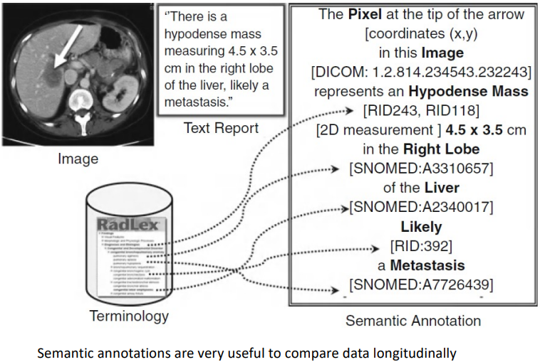

## Image Processing

Methods:

* Global processing
* Window/level, histogram equalization, convolution,
* filtering
* Image enhancement
* Image rendering/visualization
* Image quantitation (features)
* Image segmentation
* Image registration
* Image reasoning/classification

## Image interpretation and computer reasoning

Imaging informatics can enhance interpretation in different ways:

* Image retrieval
  + content based image retrieval
* Clinical Decision support systems:
  + Computer assisted detection (CAD)
  + Computer assisted diagnosis (CADx)

### Image retrieval

Content based image retrieval:

* Search databases for similar images with known diagnosis to improve diagnostic accuracy
* Need to derive quantitative features from the images (e.g., voxel statistics, spatial frequency content, etc…)
* Application of similarity metrics to search databases

Current challenges:

* 2D vs. 3D / nD retrieval
* Integrate image data with non-image clinical data
* Limitations in including image semantics (narrative text)

### Computer assisted detection (CAD)

The main aim is to detect a disease. CAD reviews many images and identifies those ROI that are suspicious and require closer investigation by a radiologist. The major application for CAD is screening.

Tradeoff favors false positives instead of false negatives. As for now we have successful implementation in mammography, chest X-rays and CT, CT images of the colon, PAP smears.

### Computer assisted diagnosis (CADx)

The main aim is to evaluate ROIs to suggest a diagnosis. Typically work on image ROIs, already identified as suspicious. Bayesian (probabilistic) models that correlate local features with diagnosis.

Challenges: the input ROI should be structured (semantic captured in the routine workflow)

CADx example:

